Reflections Holiday Parks Board
candidate information pack
September 2023
- 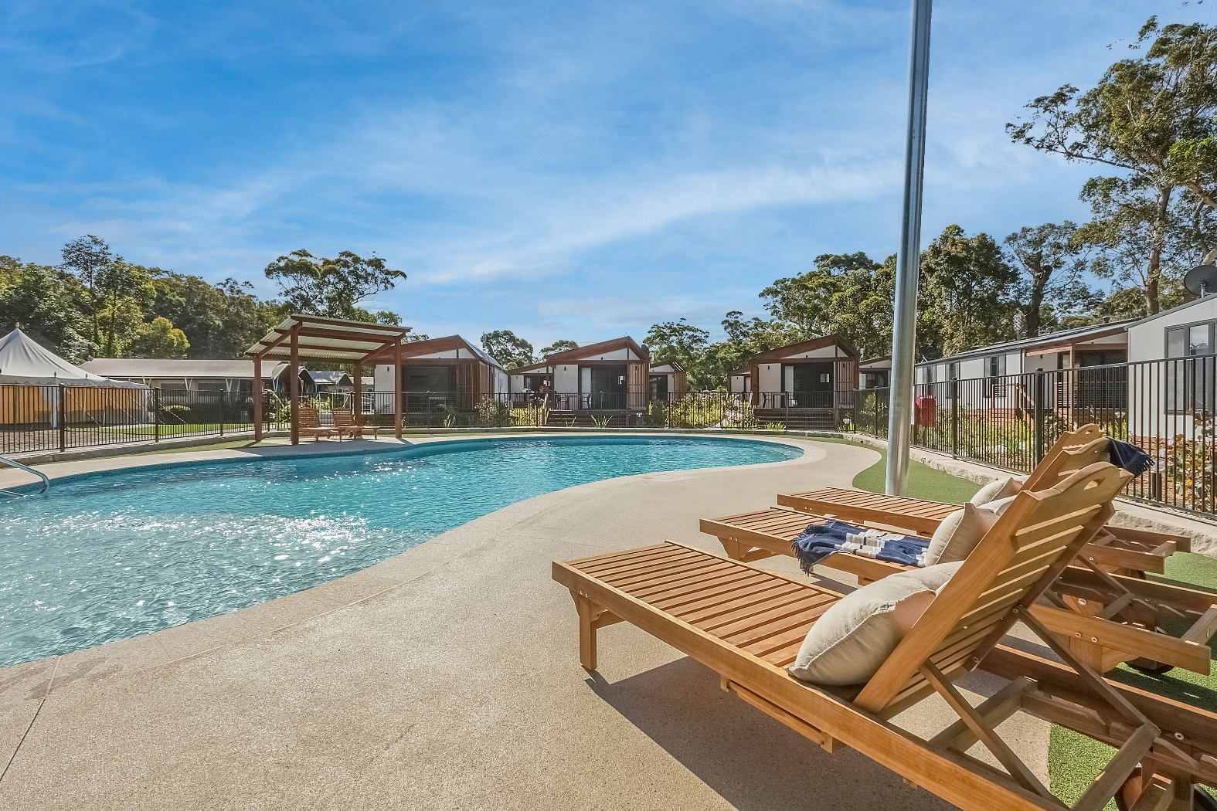

Acknowledgement of Country
The Department of Planning and Environment acknowledges that it stands on Aboriginal land. We acknowledge the Traditional Custodians of the land, and we show our respect for Elders past, present and emerging through thoughtful and collaborative approaches to our work, seeking to demonstrate our ongoing commitment to providing places in which Aboriginal people are included socially, culturally and economically.
Published by NSW Department of Planning and Environment
dpie.nsw.gov.au
Reflections Holiday Parks Board Candidate Information Pack
First published: August 2023
Department reference number: DOC23/194811
Copyright and disclaimer
© State of New South Wales through Department of Planning and Environment 2023. Information contained in this publication is based on knowledge and understanding at the time of writing, August 2023, and is subject to change. For more information, please visit dpie.nsw.gov.au/copyright

Contents
Acknowledgement of Country 2
About Reflections Holiday Parks 4
Board Overview 4
Reflections’ strategic direction 5
Position descriptions 5
Functions of the board 5
Role of members 6
Chair position 6
Skills and experience 7
Term and meeting frequency 7
Renumeration 8
Probity 8
How to apply 9

About Reflections Holiday Parks
Reflections Holiday Parks manages a portfolio of 37 holiday parks and campgrounds and associated Crown reserves located across coastal and inland regions in New South Wales. In total, Reflections manages 23,000 acres of public land, with 94% being nature reserves.
Reflections Holiday Parks is the trading name for the NSW Crown Holiday Parks Land Manager – a statutory body established under the Crown Land Management Act 2016 (the Act). The land manger is responsible for the care, control and management of Crown reserves on behalf of the people of NSW.
- Largest holiday park group in New South Wales
- Welcomes 2 million visitors per annum
- Reinvests all profit into public land
- A dynamic commercial organisation with a quadruple bottom line focus
The organisation is the first and only holiday group in Australia that is certified as a social enterprise. All profits are reinvested in the care for public (Crown) land for its preservation and the community’s enjoyment.
The land manager employs approximately 450 staff, is responsible for assets valued at more than $400 million and generated more than $117 million in economic value to regional NSW in the last financial year.
Website: https://reflectionsholidayparks.com.au/

Board Overview
The Board plays a key role in guiding the strategic direction of Reflections, bringing industry-leading knowledge, experience and relationships.
The Reflections Board consists of 7 members, including the Chairperson, who set the strategic direction for the land manager organisation.
3 positions of Board will be recruited as part of a board renewal process. One board member will also be selected as Chairperson.
The land manager Board presents a unique opportunity to contribute to social, economic, cultural and environmental management of some of NSW most iconic locations, ensuring these locations are managed appropriately for current and future generations.

Reflections’ strategic direction
Reflection’s purpose is to share nature’s playground with its guests in a way that gives back to local communities. Its goal is to become Australia’s first B Corp holiday park group and deliver $1.3 billion in cumulative economic value to regional NSW by 2030.
Last year, Reflections launched its 2030 Strategic Plan to grow its operations and customer experience, while becoming an industry leader in environmental sustainability and social impact, including working with Aboriginal partners to realise cultural and economic opportunities on reserves managed by Reflections. It also changed its operating model (from a mix of contractor and employee run parks, to all employee-run parks) to enable it to deliver these changes at scale.
The organisation is in a fast growth stage. In addition to continuing its Quadruple Bottom Line focus (financial, social, cultural, environmental), Reflections is focussed on leveraging technology to enhance customers’ experience, developing leading products that deliver a unique customer experience, and continuing to invest in its people’s growth and career opportunities across the group. Our strong emphasis on environmental sustainability is driving our investments in sustainable practices and green energy solutions, showcasing our dedication to responsible environmental stewardship and the enduring welfare of society.
Reflections’ values are: Care Deeply; Make A Difference; Grow Together; and Say It, Do It. View how these values are brought to life here (Password: reflections)
- The 2030 Strategic Plan is available here. Highlights from FY22 are available here.
Find out more about Reflections’ Profit for Purpose and quadruple bottom line here. (Enter Password: reflections)

Position descriptions

Functions of the board
The board carries out the following functions:
- provide strategic direction to ensure the organisation is effective, achieves its purpose and maximises shareholder value
- oversee a governance framework, including a compliance framework to ensure that its holiday park operations are managed in accordance with the Crown Land Management Act 2016 (NSW), Holiday Parks (Long-term Casual Occupation) Act 2002 and other relevant legislation
- oversee organisational and financial performance, including work health and safety obligations
- oversee a risk management framework to actively monitor and mitigate risks
- oversee frameworks for capital expenditure
- oversee the appointment and performance of Chief Executive Officer
- provide input and direction on stakeholder management
- establish board committees as needed
The functions of the board may be revised or expanded in consultation with, or as requested by, the Minister for Lands and Property, from time to time.

Role of members
Members are responsible for:
- supporting the board to perform its functions and acting in the interest of the Board as a whole
- attending all meetings and participating in discussions,
- providing written and verbal input into issues, as required
- meeting the statutory obligations under the Act

Chair position
A new Chairperson will be selected as part of the board renewal process. Both the existing and new board members can apply for the Chairperson role.
The role of the Chairperson will be to:
- providing leadership and ensuring that the board performs its functions
- setting the agenda in conjunction with the secretariat
- conducting meetings according to standard meeting procedure and the terms of reference
- facilitating frank and open discussion on the agenda items in a timely manner
- presenting the board’s views including unanimous, majority and/or divergent views on discussion topics
- ensuring an appropriate management strategy is in place to document and manage conflicts of interest
- facilitating the flow of information to members and stakeholders
- acting as spokesperson for the board
- liaising with the Minister and Department of Planning and Environment on operational matters.

Skills and experience
The Reflections Board is a skills-based board. Board candidates must have one or more of the priority skills outlined below. Candidates who also have one or more of the desirable skills outlined below will be highly regarded.
Priority | - Asset Development / Property Management  - Tourism and commerciality  - Digital and technology  - Environment and sustainability  - Government relations  - Community stakeholder management  - Customer focussed industries
Desirable | - Governance, audit and risk management  - Organisational performance  - Marketing communications  - Strong interest in camping/outdoor adventure.
The recruitment process will also seek to attract a diverse range of candidates and will consider inclusion of:
- Gender equity
- Aboriginal and Torres Strait Islander
- Cultural and linguistic diversity
- Lesbian, gay, bisexual, transgender, queer, questioning, intersex, asexual +
- Disability inclusion
There will be a focus on ensuring multicultural diversity is achieved. This will ensure the that a diverse range of beliefs and interests will be considered and is reflective of the community at large.

Term and meeting frequency
The initial term of the new board members will be for five years.
The Board will meet at least seven times each year, as required to undertake its functions and provide adequate governance. Board members will be required to travel domestically occasionally to fulfil their duties and attend in Park Board meetings.
Board Members also form the membership of 3 sub-committees:
- Audit and Risk Committee
- Asset Development Committee
- People and Remuneration Committee

The Board may also need to consider matters out of session from time to time.

Renumeration
The Board was classified under the Classification and Remuneration Framework for NSW Government Boards and Committees at a level A3 with the following remuneration:
Chair: annual remuneration of $70,000
Members: annual remuneration of $35,000.

Probity
All board members will be subject to probity checks prior to appointment.

How to apply
Applications for the position will need to include the following:

Applications must be submitted through www.iworkfor.nsw.gov.au

To arrange a confidential, non-mandatory conversation regarding the roles, please contact both Michelle Wood at Michelle.Wood@crownland.nsw.gov.au (Wednesday-Friday) and Sarah Lees at Sarah.Lees@crownland.nsw.gov.au (Monday-Wednesday).

