The Blue Mountains Branch manages 73 parks and reserves, including the Greater Blue Mountains World Heritage Area. We protect many threatened plants and animals, such as the only known grove of Wollemi Pines, and several highly significant Aboriginal Places.
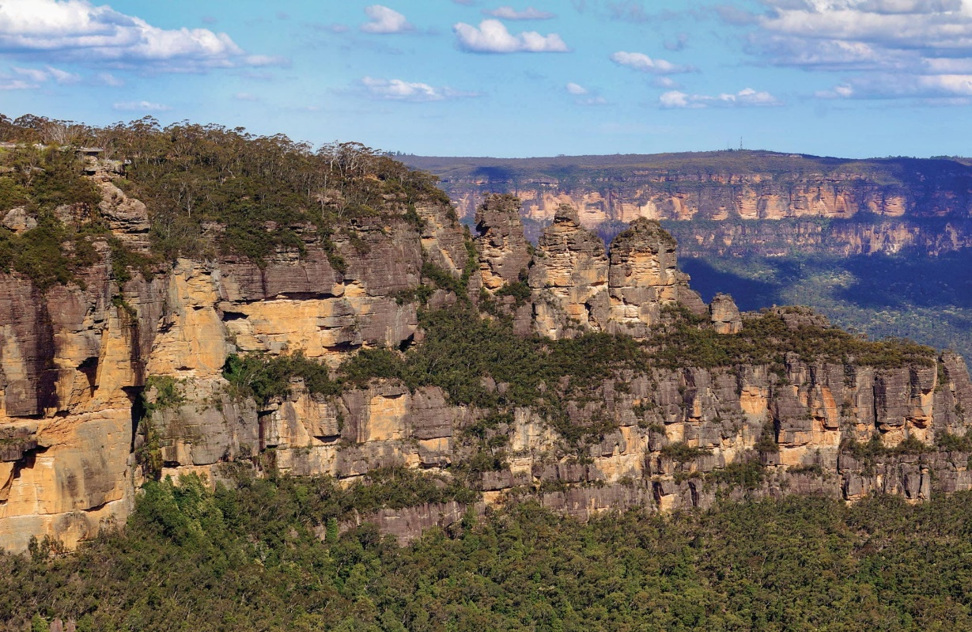
The Three Sisters
Every year, more than 8 million people visit our iconic locations, like the Three Sisters or Govetts Leap, or heritage-listed historic sites, like Hill End and the Wombeyan Caves. We manage over 400 km of iconic walking tracks, 40 campgrounds and 175 lookouts.
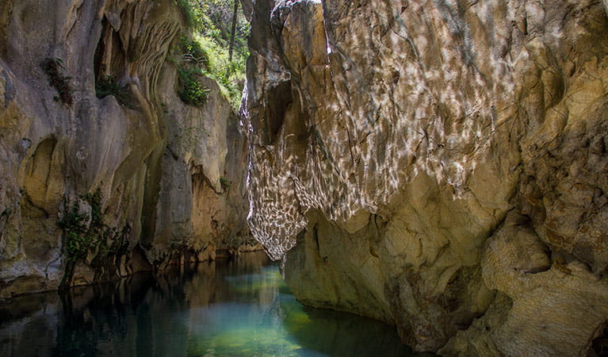
Wombeyan Karst Conservation Reserve

