The Greater Sydney Branch manages 20 nature reserves, 16 national parks, 8 state conservation areas, 3 historic sites and 9 regional parks. This includes Royal National Park, renowned as the second oldest national park in the world, and Ku-ring-gai Chase National Park, the second oldest national park in Australia.
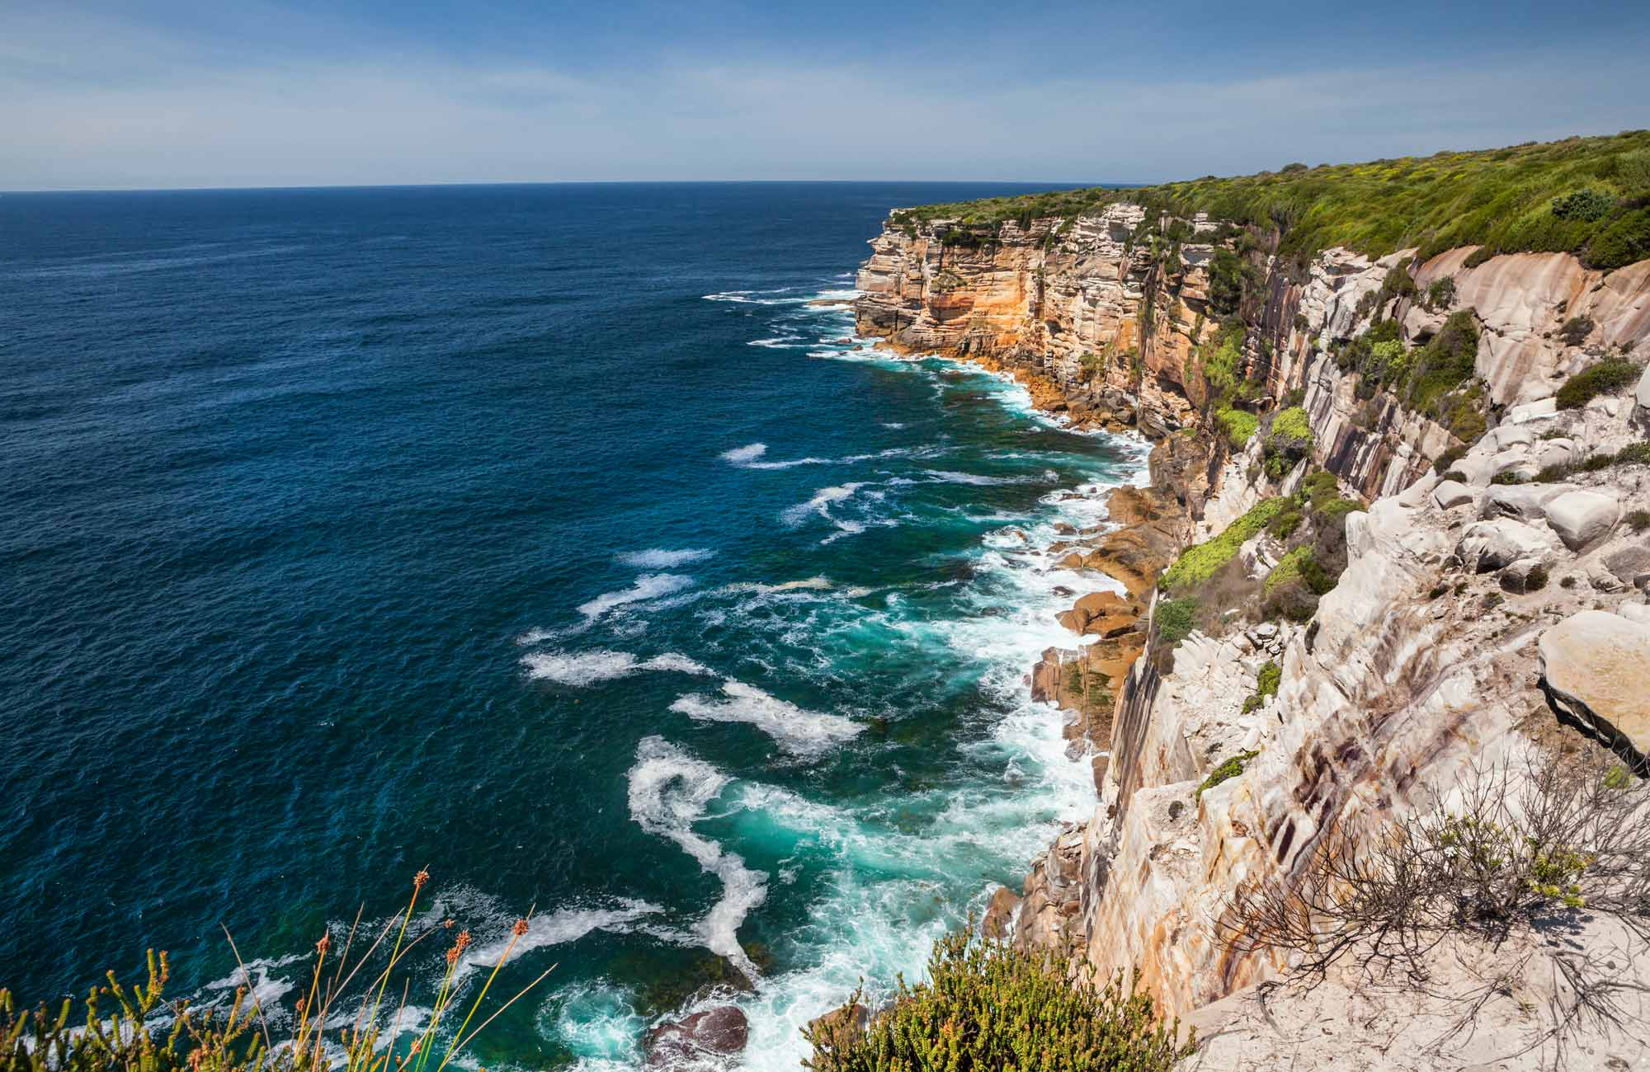
Royal National Park
We work closely with First Nations people to care for diverse landscapes, from dramatic Eucalypt forests in the East to Cumberland Plain Woodland in the West. Our parks host more than 19 million visits each year and we are delivering an ambitious program to improve visitor infrastructure in our key precincts, many of which are State Heritage-listed.
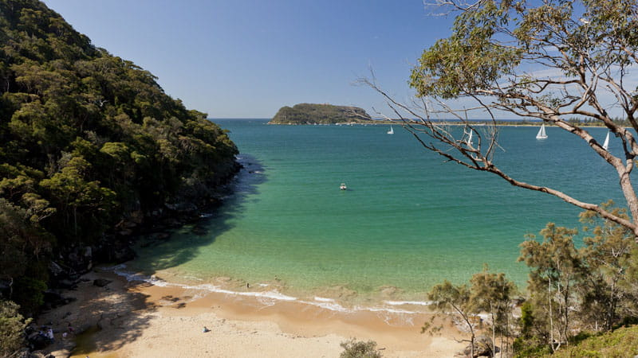
Ku-ring-gai Chase National Park

