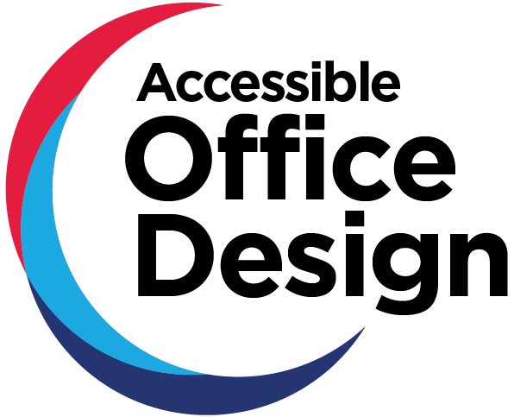
  - Framework

Guide
September 2021
Guide | Accessibility Criteria | Design Requirements
Publication and Contact Details
© State of New South Wales (Public Service Commission)
This publication is licensed under Creative Commons Attribution 3.0 Australia (CC BY 3.0 AU) licence, except as noted below. Terms and conditions of the licence can be viewed at: https://creativecommons.org/licenses/by/3.0/au/legalcode
We request attribution as: “NSW Government Accessible Office Design Guide (September 2021)] © State of New South Wales (Public Service Commission)
Without limiting the terms of the CC BY 3.0 AU, any person using material from this publication is required:
- to observe and retain the copyright notices that accompany this publication
- ensure that appropriate attribution to the Public Service Commission is made, and
- refrain from implying that the Public Service Commission endorses any use of this publication
Material not licensed under the Creative Commons Licence
The following material is not licensed under the Creative Commons Licence:
- the State’s Coat of Arms, NSW Government Waratah brand and any other symbols,
logos or trademarks of the State of NSW or of any department or agency of the
State (unless incidentally reproduced on an unaltered copy of this document).
- the Accessible Journey Framework, the copyright in which is owned by FUNKTION Pty Limited.
- all images are property of Peter Morris/Sydney Heads.
- any third-party material (whether or not identified as such) unless expressly stated
to be published under the Creative Commons Licence.
Acknowledgement
The Accessible Office Design framework
Accessible Office NSW Government project team – Gail Le Bransky, Alison O’Loughlin, Stace Fishwick, Nicole Rossini, Alyce Umback, Tiffany Heath, Mischa Warren & Helen
Project partners – FUNKTION Pty Limited Access and Inclusive Design specialists
Special thanks – Disability Employment Network Chairs and members, and NSW Government employees with disability who contributed to the evidence base for the framework
Contributors – Vision Australia
Photography – Peter Morris
Identity and design – Twisted Pear Concepts
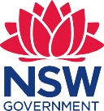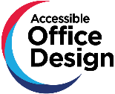
NSW Public Service Commission
Level 4/255 George Street
Sydney NSW 2000
Telephone: (02) 9272 6000
Email: enquiries-psc@psc.nsw.gov.au
Inclusion is about removing the barriers
People with disability are ordinary people living with impairments who can be enabled and empowered to fully participate as equal members of society. To enable equity and fairness, inclusive and barrier free environments are required. What ‘disables’ a person with an impairment is not their impairment but the barriers created in our environments. Barriers are not just physical - they can also include attitudinal and societal barriers such as stigma and bias, as well as policy and other systemic barriers.
Our decisions require empathy to understand our audience needs, the humility of thought to challenge our own assumptions, and the openness to discover new ideas and practices that afford everyone the dignity and respect of equal access.
Greg Alchin
Principal Accessibility Specialist, Service NSW
Table of Contents
Foreword 6
Message from Property & Development NSW 7
1. Executive summary 8
1.1 Who it is for 8
1.2 Designing accessible offices 9
1.3 Using this framework 9
1.4 Supporting information 9
1.5 Accessible and inclusive products and services 10
1.6 COVID-19 10
2. Designing accessible offices 11
2.1 Who accessibility benefits 11
2.2 Disability in the workplace 12
2.3 People with disability face challenges at work 13
2.4 What you should consider 14
3. Using this framework 17
3.1 What it covers 17
3.2 How to measure performance 20
4. Supporting information 24
4.1 Data collection 24
4.2 Related documents 24
4.3 Document control 26

Foreword
Universal design is about creating an inclusive society.
The Accessible Office Design framework is a joint initiative between the NSW Public Service Commission and Property & Development NSW (Department of Planning, Industry & Environment) aimed to make workplace design and fit out more accessible in new and existing NSW Government buildings.
The framework is for anyone who procures, designs, builds, refurbishes, manages or maintains NSW Government offices.
The intent of this framework is to assist the public sector and the property industry to integrate the principles of universal design into strategic planning and design to meet the needs of a wide range of employees, now and into the future.
We know from research, and what our employees tell us, that lack of accessibility in workplaces is a barrier to retaining and employing more people with disability. This framework aims to address and remove this barrier, and to assist agencies to meet the Premier’s Priority of delivering a world class public service, to encourage representation of at least 5.6% of people with disability across our 400,000 person strong workforce.
The NSW Government’s clear direction is to create consistent, dynamic, efficient, fair, flexible and inclusive workplaces across the whole of Government.
Embedding universal design into our workplaces is a necessary step in making them accessible for everyone and will allow for all people to feel truly included and respected in their place of work.
As Public Service Commissioner, I am proud, alongside the Secretary for the Department of Planning, Industry & Environment to deliver the Accessible Office Design framework.
Kathrina Lo
NSW Public Service Commissioner
Kiersten Fishburn
Secretary, Department of Planning, Industry & Environment

Message from Property & Development NSW
Our workplaces should work for everyone.
The Accessible Office Design framework takes the NSW Government beyond compliance to ensure our workplaces accommodate a wide variety of employee needs, and importantly supports the NSW Government’s goal to become an employer of choice for people with disability by making our workplaces truly inclusive. This framework applies to all NSW Government tenanted commercial office buildings across metro Sydney and throughout regional NSW.
Striving for the gold standard for new buildings
We recommend that all new NSW Government tenanted office buildings strive for the gold standard as it represents the best-practice accessibility standard. For existing buildings, which may be constrained by factors such as location, heritage or lease arrangements, the framework provides a pathway to achieve a higher level of performance across six journey stages.
Over time, the framework will make it easier for NSW Government cluster asset facility leads and industry stakeholders to go beyond compliance with accessibility regulation and embed best practice universal design into each workplace.
By training our property and workplace people, including cluster asset facility managers, to use the self-assessment tool, we will also deliver on our objective of developing in-house public sector expertise in accessibility design.
Inclusive design reflects the widest range of people’s requirements – and by considering both the commercial and human impact we can make better business decisions, future proof our assets and make our workplaces truly inclusive and work for everyone.
I am proud of the work done by Property & Development NSW in partnership with the NSW Public Service Commission on this important initiative.
Leon Walker
Deputy Secretary Property & Development NSW Housing & Property Group Department of Planning, Industry & Environment

1. Executive summary
Accessible Office Design is a performance framework for making office design and fitout more accessible in both new and existing buildings.
This guide explains who will benefit from accessibility, why it is important and what decision-makers should consider when creating accessible and inclusive office spaces. It also outlines the intended users of the performance framework (the framework), and how they can apply universal design principles and assess performance.

1.1 Who it is for
Anyone making government office decisions should use the framework
The framework is for anyone who procures, designs, builds, refurbishes, manages or maintains NSW Government offices.
It will inform decisions about government property procurement, and can help assess the leasing potential of future buildings.
Users of the framework will include:
- senior leaders, decision makers and other employees in cluster departments and agencies
- project and facilities managers
- leasing agents, developers and builders
- architects and interior designers
- work health and safety professionals
- consultants.
The NSW Government is working to apply universal design to its offices, and create workplaces that are consistent, dynamic, efficient, fair, flexible and inclusive.
This work aligns with other strategic planning commitments, and the framework will help the public sector and property industry adopt universal design principles.
The framework supports the:
- Government’s commitment to making all public sector roles flexible, using an ‘if not, why not’ approach
- Whole of Government Office Accommodation Policy and other government policies about accommodation and real property
- Premier’s Priority of a World Class Public Service which includes the commitment to increase the number of employees with disability in government sector roles
- State Priority of delivering strong budgets.

1.2 Designing accessible offices
Best practice design means creating environments that suit a diverse range of users. It is flexible enough to accommodate people with disability, including those who have a non-visible disability or others who choose not to share that information at work.
People with disability often face unintended barriers in the workplace, and poor accessibility may mean they cannot take or stay in a job. The framework outlines how to create workplaces that give everyone a welcoming and empowering experience.
In this way, the framework will help the NSW Government meet its target to double the proportion of public sector employees with disability to 5.6% by 2025 and create a more inclusive government sector, over time. It uses the 7 principles of universal design to encourage not just compliance with minimum accessibility requirements, but best practice design for inclusion.

1.3 Using this framework
The government is working to apply universal design principles to its offices, and the framework outlines features you should consider along the way. It breaks down these considerations across 6 journey stages an employee will experience during a workday.
The framework is made up of 6 journey stages an employee will experience during a work day

1.4 Supporting information
To help create the framework, we engaged with NSW public sector employees through focus groups and through the Accessible Office Design Survey. We heard from over 690 public sector employees with disability, which helped us address the needs of people who experience cognitive, physical, psychological, psychosocial or sensory diversity.
The framework complements the accessibility requirements that already apply to government workplaces and helps to ensure employees and visitors with disability have the same rights as others in the workplace.
The framework is a living document that should be reviewed regularly alongside periodic amendments to the ‘National Construction Code’, the Disability (Access to Premises – Buildings) Standards 2010 and the Australian Standards for Access and Mobility (AS1428 series).

1.5 Accessible and inclusive products and services
Accessibility is not just important for workplaces; it is also important to our work practices. The NSW Government expects that all public sector employees can meet the basic level required to provide a better experience for people using our services. Further information on digital accessibility and inclusion can be found on the Digital NSW Design Standards page.

1.6 COVID-19
All employers are required to manage safe workplaces for workers and visitors. This framework complements the current efforts of the NSW Government to design a post COVID-19 workplace that allows for:
- Layout and density that help social distancing
- Technology to allow for virtual meetings to reduce business related travel
- Shared meeting room spaces that are safe and accessible
- Hygiene stations integrated into workplace design
The framework’s accessibility criteria and design requirements will help you prioritise your work around accessibility to achieve bronze, silver or gold performance.

2. Designing accessible offices

2.1 Who accessibility benefits
Office environments should meet a range of employee and visitor needs
Designing for inclusion means:
- making places safe and easy to use
- intelligently meeting diverse employee and visitor needs
- making activities more engaging for more people
- offering independence and choice
- enhancing dignity and respect
The Disability (Access to Premises - Buildings) Standards 2010 defines accessible design as having “features to enable use by people with a disability”.
Universal design goes a step further by making places usable for people regardless of their age, gender identity, size or ability. More people can use environments, products and services that are universally designed, without adaptation or specialisation.
The goal of this framework is to broaden the scope of accessibility in office design to better suit a diverse workforce.
Universal design engages diverse groups
Universal design encourages and promotes best practice by considering people with diverse needs in order to enhance usability, participation and independence. It is flexible enough to accommodate people who do not have a visible disability, and those who do not wish to disclose their disability at work.
A social model of disability proposes that what makes someone disabled is not their medical condition, but others’ attitudes about their disability, and the physical and environmental barriers they face in the community.
For example, a person in a wheelchair is disabled by their inability to get into a building if the entry has steps. A person with a chronic illness who requires rest periods may not be able to work without flexible arrangements.

2.2 Disability in the workplace
Disability is part of human diversity. Approximately one in five people in Australia have a disability and this proportion increases as we age. Disability may be visible or hidden, permanent or temporary and may have minimal or substantial impact on a person’s abilities..
A social model perspective does not deny the reality of impairment nor its impact on the individual. However, it does challenge the physical, attitudinal and social environment to accommodate impairment as an expected incident of human diversity.
Universal design activates engagement, independence and participation. To this end, this framework has been developed to incorporate into design the needs of people who may experience the following:
Examples
Learning, cognition and neurodiversity | - Learning, memory, attention or organisational difficulties  - Communication difficulties  - Autism Spectrum Disorder  - Dyslexia  - Acquired Brain Injury
Physical | - Chronic illness or pain  - Temporary impairment or injury  - Medical needs  - Mobility difficulties, such as using a manual or powered wheelchair, mobility scooter or walking aid, or having reduced walking tolerance  - Short stature  - Upper limb impairment
Psychological and psychosocial | - Short-term, long-term and episodic mental health conditions  - Mood disorders, such as anxiety or depression  - Post-traumatic stress disorder  - Psychiatric illness, such as schizophrenia
Sensory | - Blindness, low vision or vision impairment  - Deaf or hard of hearing  - Sensitivity to light, sound or smell
NSW public sector employees with disability
In the most recent Workforce Profile Report an estimated 2.4% of NSW public sector employees indicated that they have a disability. The same report indicated that people over the age of 55 make up 23.6% of the public sector workforce. This is relevant as age related disability is a significant factor in the workplace. Vision impairment, reduced mobility and arthritis are all common issues that appear as we age.
The development of the framework took a user-centred approach. We surveyed 670 NSW government employees with disability and the findings were incorporated into the framework.
Of the employees who participated in the Accessible Office Design Survey:
- 65% have a physical disability
- 51% have a medical issue like a chronic health condition
- 44% are neurodiverse
- 38% have a mental illness
- 18% are deaf or hard of hearing
- 14% have a vision impairment

2.3 People with disability face challenges at work
If government workplaces are inaccessible, agencies may hire and retain fewer people with disability as they may experience unintended barriers. One broken link on an employee’s journey can cause frustration or stress, require undue effort, or even prevent access entirely.
Employees with disability who responded to the Accessible Office Design Survey identified their top 10 challenges at work as involving:
- desks or workstations
- acoustics
- thermal comfort
- meeting rooms
- furniture such as cupboards, drawers and storage
- standard computer equipment
- technology and audio-visual equipment
- conference rooms
- lighting and colour
- collaborative spaces.

The most recent Workforce Profile Report found that 0.6% of employees with disability requested adjustments in the workplace. But in the most recent People Matter Employee Survey, those employees reported that more than one-third of the adjustments (36%) were unsatisfactory or incomplete. For example:
- they did not achieve full and independent access
- the physical workplace or digital technology could not be made accessible.
Disabilities are not always visible
A significant proportion (46%) of people who completed the Accessible Office Design Survey noted that they have not told their employer about their disability.
Many disabilities, like mental illness, are not visible. Others, like deafness, are not immediately obvious. Some occur intermittently and do not always affect the person.

2.4 What you should consider
The framework uses the 7 principles of universal design
Creating accessible and inclusive workplaces embraces diversity, and gives employees and visitors a welcoming and empowering experience at work.
The framework aims to do this by addressing features in offices that the laws and standards in section 4.2 of this guide do not cover.
The framework’s accessibility criteria and outcome statements are based on the following 7 principles of universal design. These suggest building features should do more than just comply with minimum accessibility requirements; they should achieve best practice in disability inclusion and usability for all employees and visitors.

Principle | Details
1. Equitable use | The building design:  - appeals to and welcomes people with diverse abilities, to broaden participation  - creates a sense of belonging  - avoids segregating any users.
2. Flexibility in use | The building design:  - accommodates individual preferences and abilities  - allows people to use its features in more than one set way.
3. Simple and intuitive use | Building features are easy to understand regardless of someone’s experience, knowledge, language skills, or concentration level.
4. Perceptible information | Buildings and spaces:  - provide essential information in different modes, such as written, symbolic, tactile or auditory  - communicate with all users effectively.
5. Tolerance for error | The building design:  - minimises, isolates or eliminates features that could be hazardous or inconvenient  - anticipates and minimises negative consequences of accidental or unintended actions.
6. Low physical effort | The building features:  - are comfortable and convenient to use  - minimises fatigue
7. Size and space for approach and use | Building features:  - provide a clear path of travel to and from key features  - allow enough space for anyone to approach, reach and use when seated of standing
Adapted from: The Centre for Universal Design | NC State University

The location of potential new offices is important
As you will see in the next section, the first stage of the framework – arriving and leaving – addresses office location. The performance levels for this stage outline an ideal scenario close to public transport and with pick-up and drop-off areas.
These features are especially important to employees with disability and, while they may not be achievable for current offices, you should consider them when assessing potential properties and signing new leases.
Look closely at the design requirements in this section and work with third parties, such as transport services and local governments, to address issues and barriers to access wherever possible.
The framework provides NSW Government offices with a new benchmark for accessibility

3. Using this framework

3.1 What it covers
There are 6 accessible journey stages
The framework is a tool to inform office design and fit-out. It provides benchmarks to make features more usable and to improve the employee experience, even in areas that may already meet minimum accessibility requirements.
It covers 6 stages an employee will experience during a workday:
- arriving and leaving
- approaching and entering
- moving through buildings
- using work areas
- using amenities
- using communication systems.
These stages show that access is a chain of events or journey. For each stage, the framework:
- identifies key building features that impact on accessibility
- measures how accessible certain building features are
- includes guidance on the accessibility criteria needed to achieve bronze, silver or gold performance levels.
Accessible Office Design Framework Journey Stages
Stage | When employees and visitors…
Arriving and Leaving | move to and from a building’s property boundary by car, foot, public transport or taxi
Approaching and Entering | approach the building entrance from site arrival points, then enter or exit through foyers and reception areas
Moving Through Buildings | navigate inside the building using:  - work areas  - connections between office floors  - corridor links  - emergency exits
Using Work Areas | use designated work areas including:  - workstations  - printing areas  - conference and meeting rooms  - collaborative spaces
Using Amenities | use purpose-built amenities like:  - toilets  - kitchens  - personal storage  - multi-use rooms  - assistance animal areas
Using Communication Systems | use building and operational systems like – booking, destination control, signage and sign-in systems – to understand and access different areas and services
Accessiblity criteria and design requirements help users of the framework prioritise
Two key sections sit within the framework:
- accessibility criteria
- design requirements
The accessibility criteria provide an overview of the benchmark for Bronze, Silver and Gold. This is reflected in the outcome statements for each building element.
Each performance level has a set of accessibility criteria that shows how to incrementally improve building features for an accessible workplace.
For example, the criteria for Stage A4 Arriving and Leaving: Walking Surfaces state that to achieve bronze performance, walking surfaces must be firm, even, slip-resistant and free of trip hazards. To achieve silver, they must stop water from accumulating. And for gold, they must have textures and pathway edges that help with wayfinding.
Accessiblity Criteria
A set of outcome statements that define key criteria to achieve different levels of design performance.
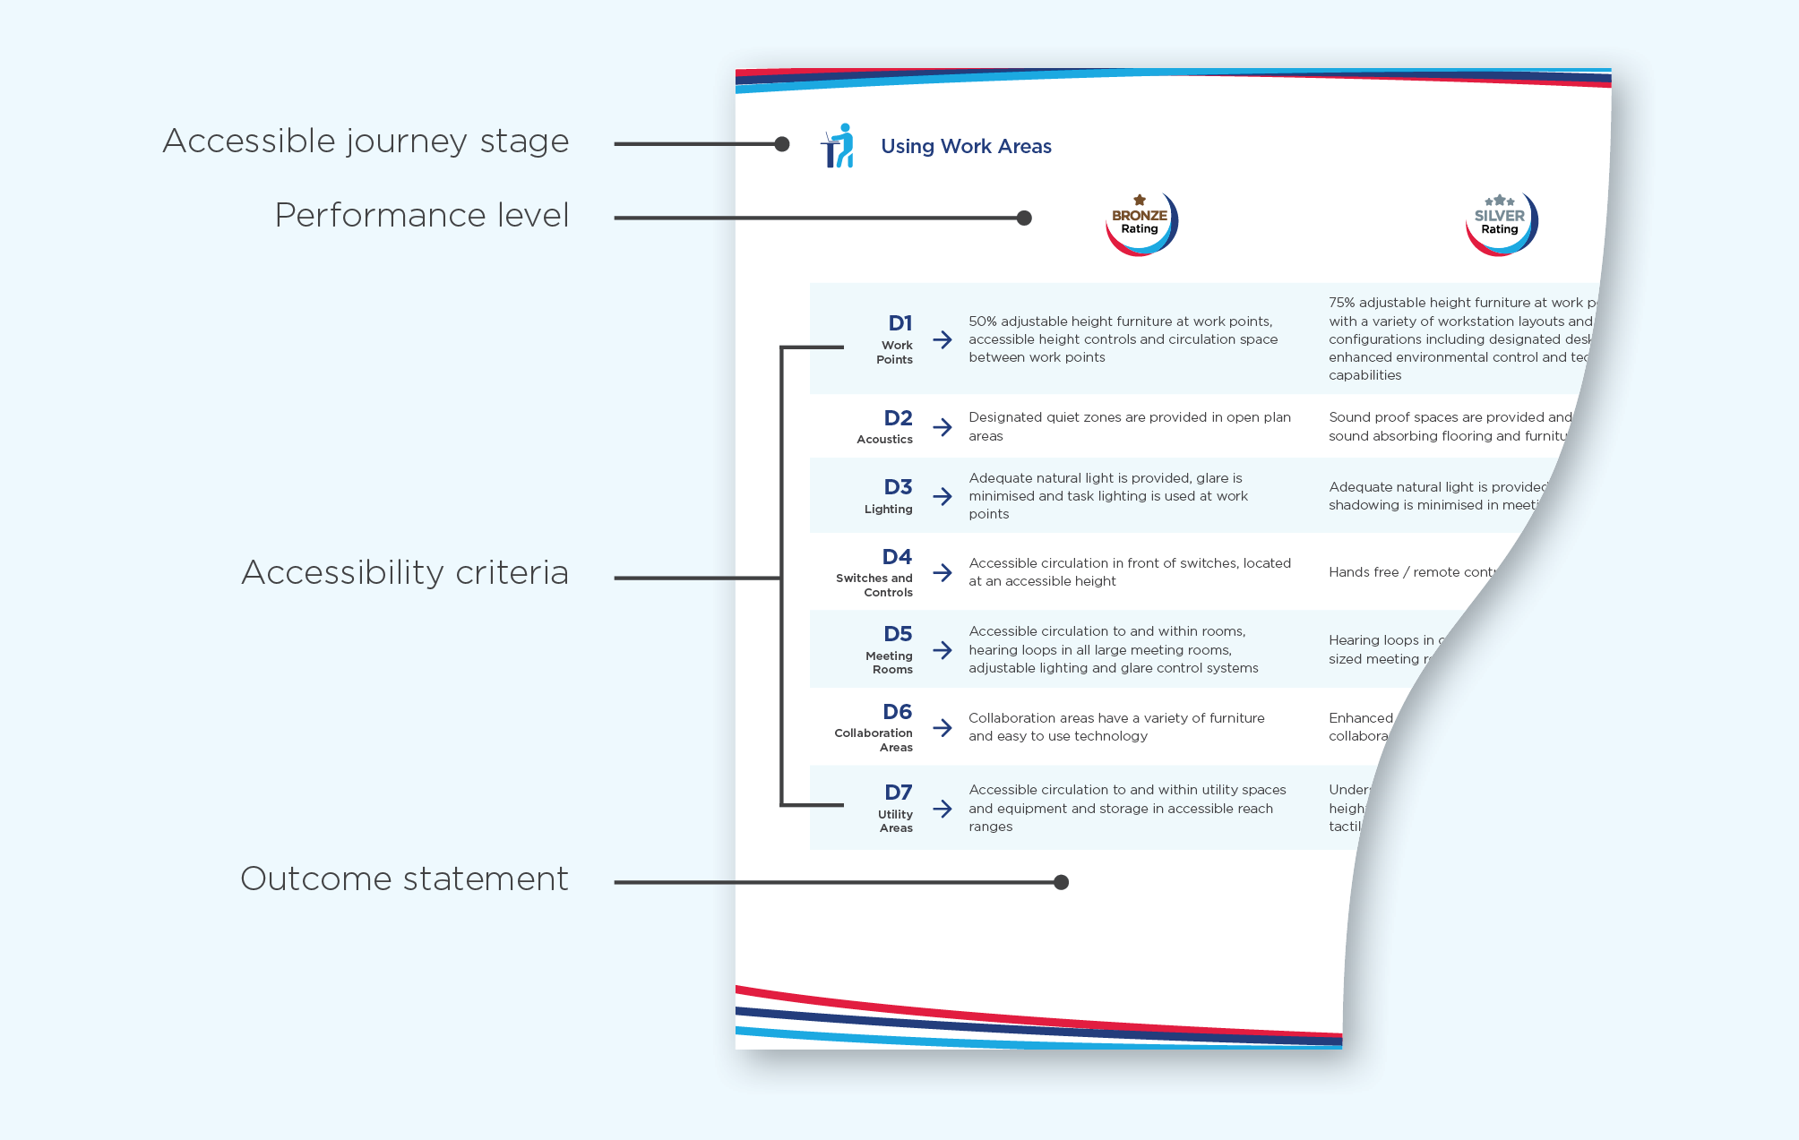
Design Requirements
Detailed requirements to achieve different levels of design performance.
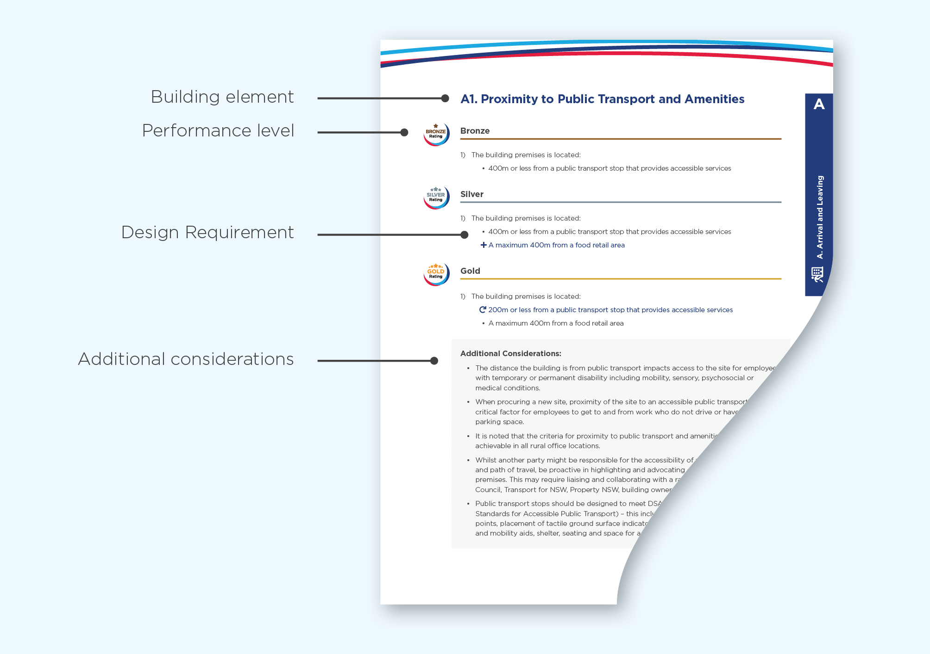
The design requirements then provide extra design details for those users who need them. They help project teams make key design decisions by outlining:
- specific features and measurements to meet the accessibility criteria
- best practice features that exceed minimum accessibility requirements.
This section also includes areas that are often overlooked in the design process, or that employees with disability have reported as creating significant barriers to accessibility.
For our walking surfaces example above, the design requirements include details around surface materials and slip resistance.
Together, the accessibility criteria and design requirements prioritise what you should focus on when making buildings more accessible.

3.2 How to measure performance
There are 3 benchmark performance levels
The framework sets the criteria, outcomes and requirements to achieve 3 defined performance levels:
- Bronze
- Silver
- gold (best practice in universal office design).
Each level builds on the features in the one before and reflects enhanced outcomes. This helps to standardise how universal design and accessibility are delivered across new and existing government office buildings.
Performance level | 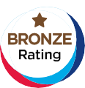
Level details | This level provides basic accessibility for a diversity of employees and focuses on features that are critical to accessibility:  - accessing and moving through the building  - minimising physical barriers that may prevent an employee from getting to the site and doing their job with little help. | This level broadens the scope of design to improve usability and increase employee independence. | This level reflects universal design principles by:  - offering more flexibility, choice and personalisation  - optimising the design by consistently delivering the most accessible and inclusive environments for all employees.
Building / tenancy details | The building / tenancy:  - complies with access and mobility requirements in the Disability (Access to Premises – Buildings) Standards 2010 and National Construction Code  - has some additional accessibility features beyond compliance with minimum standards  These features could prevent costly retrofits and individualised adjustments. | Integrated design features:  - provide enhanced accessibility for employees with different types of disability  - improve their overall ease of use and comfort.  More generous dimensions and extra features that will help employees be more independent. | Building features:  - maximise independence and dignity  - can adapt for a growing range of personal preferences in the future  - align with other systems and operational management processes.
New buildings should strive for the gold standard
The Disability (Access to Premises – Buildings) Standards 2010 and Building Code of Australia set the minimum design requirements for disability access. All new buildings, as well as existing buildings that are being refurbished even in part, must meet these requirements.
The bronze level requires a building to meet the accessibility requirements in the Premises Standards and Building Code of Australia (plus some additional requirements). The framework goes beyond minimum accessibility compliance and encourages all new government buildings to strive for the gold standard.
However, it acknowledges that existing buildings may struggle to fully meet these requirements. Heritage buildings, topographical constraints and lease agreements will likely affect their performance. The silver and bronze standards may be more appropriate and achievable for existing and refurbished buildings.
If you’re not familiar with the legislative requirements and standards for accessibility, you will need the assistance of an access consultant. They have the technical expertise to assess existing and proposed buildings for compliance with the accessibility requirements of the Access to Premises Standards and the National Construction Code.
The figure (1) below shows the expected relationship between performance level and building age.
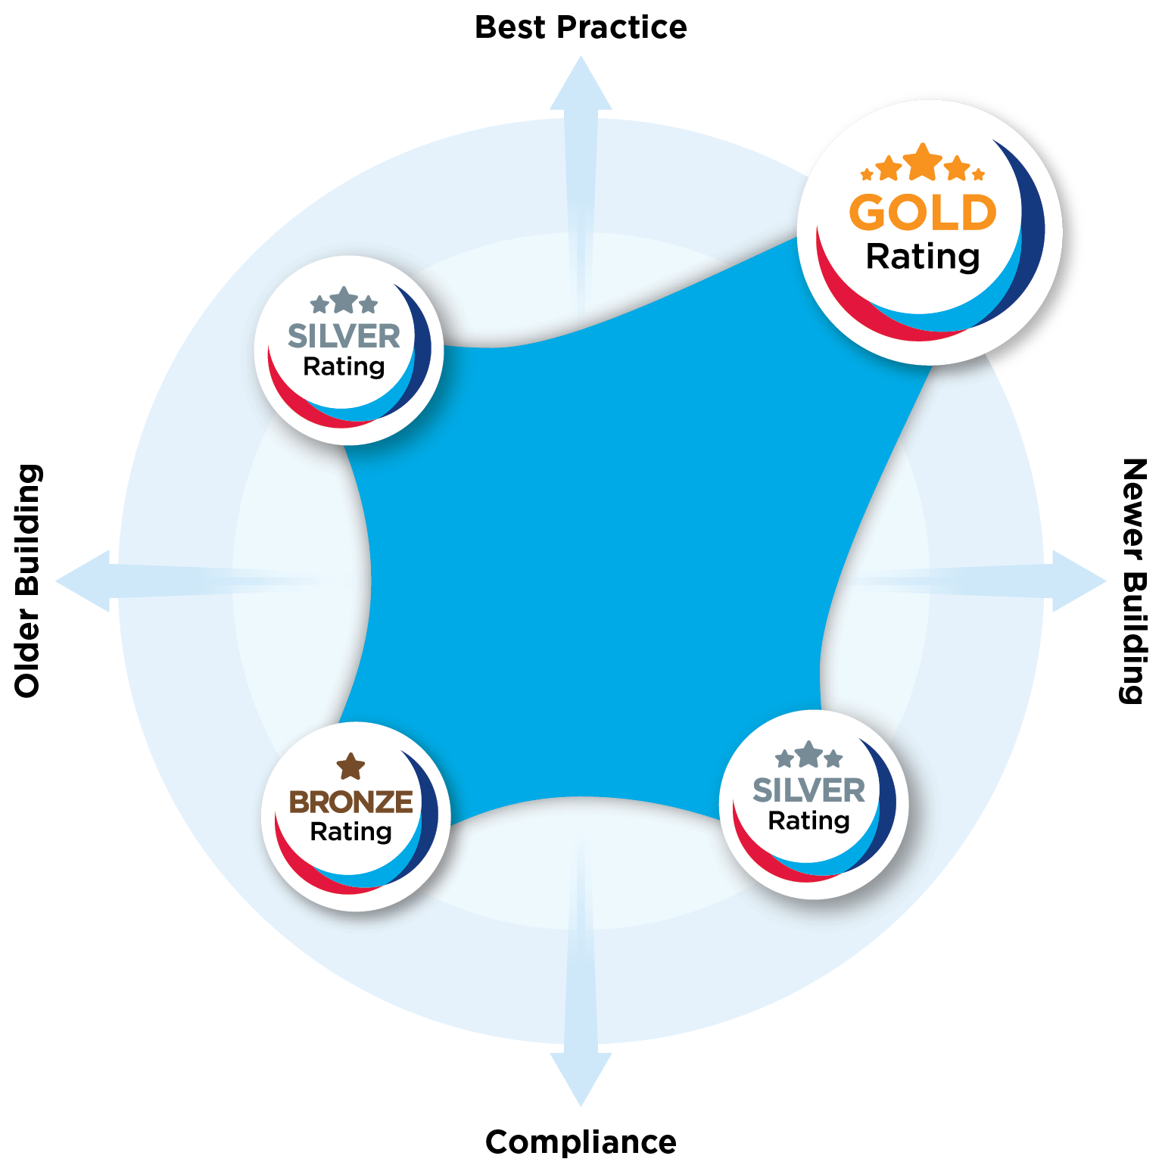
Figure 1
The framework complements other Australian laws and standards

4. Supporting information

4.1 Data collection
The data that supports this framework has come from the:
- Accessible Office Design Survey
- Workforce Profile Report
- People Matter Employee Survey
Nearly 80% of public sector employees self-reported on diversity in the People Matter Employee Survey.
The diversity data in this framework relies on a culture of inclusion that encourages employees to self-report their diversity characteristics to their employing agency. In 2020, the public sector response rate was 79.8%.

4.2 Related documents
All government workplaces must meet minimum accessibility standards
Improvements in accessibility have been driven by legislation and policy frameworks that aim to eliminate discrimination against people with disability and ensure they have the same rights as others in the community.
The following laws and standards are key to strategic planning and apply to all government workplaces:
- Convention on the Rights of Persons with Disabilities 2006 (Article 9)
- Disability Discrimination Act 1992 (Cth)
- Fair Work Act 2009 (Cth)
- Disability (Access to Premises – Buildings) Standards 2010 (Cth)
- Disability Inclusion Act 2014 (NSW)
- Anti-Discrimination Act 1977 (NSW)
The framework complements other accessibility requirements

Unlike the National Construction Code and Australian standards for access and mobility, the framework is not prescriptive however it does reference requirements from these documents where applicable. The design requirements provided in this framework do not replace other standards and requirements, and you should read them alongside the following documents:
- the National Construction Code, primarily parts D3, E3.6 and F2.4
- the Disability (Access to Premises – Buildings) Standards 2010
- other government policies on accommodation.
- Australian Human Rights Commission’s Guidelines on the application of the Premises Standards (2013)
- the following Australian standards.
Standard | Title
AS 1428 | Design for access and mobility:  - Part 1: General requirements for access – New building work (2009 including Amendment 1)  - Part 2: Enhanced and additional requirements – Buildings and facilities (1992)  - Part 4.1: Means to assist the orientation of people with vision impairment – Tactile ground surface indicators (2009, including Amendment No 1)  - Part 4.2: Means to assist the orientation of people with vision impairment – Wayfinding signs (2018)  - Part 5: Communications for people who are deaf or hearing impaired (2010)
AS 2890.6 - 2009 | Parking facilities - Part 6: Off-street parking for people with disabilities
AS 1735.12-1999 | Lifts, escalators and moving walks – Part 12: Facilities for persons with disabilities
AS 3745-2009 | Planning for emergencies in facilities
AS EN 301 549:2020 | Accessibility requirements suitable for public procurement of ICT products and services

4.3 Document control
The framework will be reviewed regularly
The framework is a living document. It will be reviewed regularly alongside reviews of the:
- National Construction Code (every 3 years)
- Disability (Access to Premises – Buildings) Standards 2010.
- The NSW Disability Inclusion Plan.

