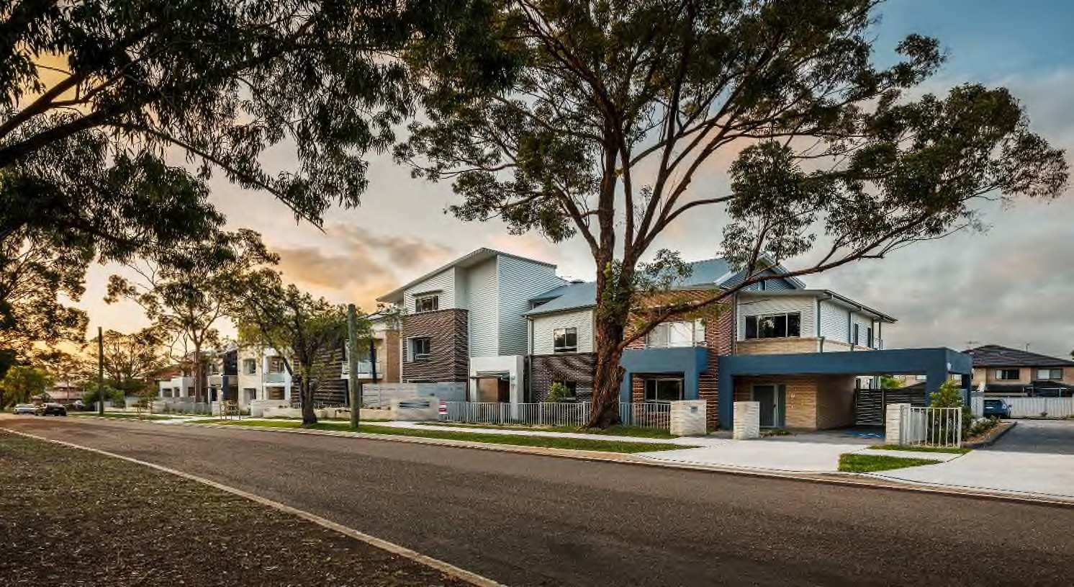
Stage 1 Submission Form
Under the Policy for Community Housing Provider-led Redevelopment of Social and Affordable Housing on LAHC-owned Land

Contents
CHP Redevelopment on LAHC Land 3
Submission Form 3
Section 1 – Submission Information 4
Section 2 – CHP Eligibility Criteria 5
Section 3 – Proposal Eligibility Criteria 7
Section 4 - Acceptance of terms and conditions 9
Section 5 – Attachments 10

CHP Redevelopment on LAHC Land
This document is the Stage 1 Submission Form for Community Housing Providers to develop on land owned by the Land and Housing Corporation.

Submission Form
New South Wales Land and Housing Corporation (LAHC) invites eligible Community Housing Provider’s (CHP’s) to make a Stage 1 Submission for redevelopment under LAHC’s Community Housing Provider-led Redevelopment of Social and Affordable Housing on LAHC-owned Land Policy (Policy). Please complete this Stage 1 Submission Form and Annexure A (the ‘A Paper’). Once completed, please email all relevant documents and attachments to CHPLedRedevelopment@facs.nsw.gov.au.
The Stage 1 Submission Form, A Paper and supporting documentation should be sent in one email with the subject line ‘CHP Redevelopment on LAHC Land – Stage 1 Submission – <CHP Name> – <Name of Project>’.
As part of providing a Stage 1 Submission, you confirm that you have read and that the submission will comply with:
- Policy: Policy on Community Housing Provider-led Redevelopment of Social and Affordable Housing on LAHC-owned Land); and
- ‘Process and Conditions’ document.
Stage 1 Submissions will be treated commercial in confidence and non-binding on both parties (the CHP and LAHC).
If you have any questions prior to making a submission, please contact the team through CHPLedRedevelopment@facs.nsw.gov.au.
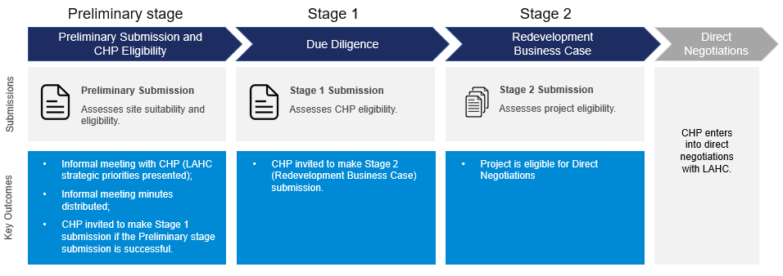
You are here

Section 1 – Submission Information
This section will be used to identify and align the Stage 1 response with the Preliminary Submission and LAHC’s assessment which occurred earlier in the Submission Process. Please contact CHPLedRedevelopment@facs.nsw.gov.au if you are unsure about your submission ID.
Table 1.1. Principal Applicant (i.e. the CHP / institution).
# | Principal Applicant | Provide details here
1 | CHP name | Click or tap here to enter text.
2 | Submission ID | Click or tap here to enter text.
3 | Proposed Site address | e.g. 11 Example street, Suburb, 1234
4 | PRN | Click or tap here to enter text.

Section 2 – CHP Eligibility Criteria

Question 5 – Confirmation that Preliminary Submission information is unchanged
Table 2.1. CHP confirmation of unchanged Preliminary Submission information.
# | Criteria | Provide response here
 |  | Yes | No
I | CHP confirms the information submitted in the CHP Eligibility Assessment as part of the Preliminary Stage is unchanged | ☐ | ☐
II | If no, please advise any change(s) | Provide response here.

Question 6 – Redevelopment Case Studies
This section will be used to assess the CHP’s capability to implement the proposed redevelopment. The CHP can respond to the criteria provided in table 2.2. An outline of an expected response has been provided in the description box. Applicants are expected to address each point where possible. Please provide a minimum of 2 successful case studies that has a similar size, cost, and complexity of the proposed redevelopment. Please limit each response to 1 page per case study.
Table 2.2. CHP evaluation criteria – CHP case studies.
# | Provide details here
I | For each case study the following should be considered:  Site Details  - Location and address  - Original condition of the site vs redevelopment  - Number of dwellings, dwelling mix, and dwelling typography  Project Overview  - Key personnel, including experience, capability and role  - Total delivery budget vs cost vs development timeline (what was the original budget, and was the project delivered on time and on cost?)  - Describe sources of funding e.g. balance sheet, external debt funding. Distinguish between construction period and operational period;  Development and Construction  - Planning pathways and approvals  - Was development done in-house or outsourced to an external developer? If the later, please identify the developer  - Outline any major issues and their remediation strategies/actions  - An assessment of the complexity of the development  Outcomes  - Social outcomes and experience  - Target cohort serviced  - High level view of tenancy relocation strategy used  References  - External references relevant to the project, including name, position, company, and contact details  Other  - Any other relevant information.
II | Enter case study 2 details here.
III | Enter case study 3 details here.

Section 3 – Proposal Eligibility Criteria

Question 7 – Dwelling Mix overview
This section will be used to assess whether the proposal is eligible under the Policy. Table 3.1. provides the CHP with the opportunity to demonstrate the potential uplift from the proposed redevelopment. Question 7 is an extension of the additional commentary required in the Preliminary stage submission which provides the CHP an opportunity to further describe how the proposed dwelling mix maximises the potential of the site under the existing planning controls. An outline of an expected response has been provided in the description box. Table 3.2. provides the CHP an opportunity to confirm that additional capital funding from LAHC is not required for the proposed redevelopment (including for relocation activities, redevelopment costs or land preparation works); and to describe the proposed plan to hand back the land, and tenant relocation plan.
Table 3.1. Dwelling mix overview. Note: this table was provided in the Preliminary submission and is included again to reflect any changes that may have arisen from the Preliminary stage informal meeting.
Total number and dwelling typology | Currently on-site  (total number) | Planning Control  (total number) | Proposed construction  (total number)
Social Housing dwellings | e.g.  2 x 2 bed unit  4 x 3 bed unit | e.g.  4 x 2 bed townhouse  5 x 2 bed cottage  4 x 3 bed villa | e.g.  2 x 2 bed townhouse  4 x 2 bed cottage  4 x 3 bed villa
Affordable Housing dwellings | Click or tap here to enter text. | Click or tap here to enter text. | Click or tap here to enter text.
Market Housing dwellings | Click or tap here to enter text. | Click or tap here to enter text. | Click or tap here to enter text.
Other  (please list in comments) | Click or tap here to enter text. | Click or tap here to enter text. | Click or tap here to enter text.

Question 8

Please provide the rationale for the above dwelling mix. An outline of the expected response has been provided in the description box. Please provide a maximum 2 page response.
Include:
- How is the potential of the site being maximised
- Explain the dwelling mix between:
  - social, affordable and market housing;
  - the mix of dwellings e.g. 2 bed vs 3 bed;
  - the dwelling typology e.g. villas vs units.
- Explain any other revenue opportunities including commercial or sub-lease opportunities
- Elaborate the design considerations in relation to the planning approval
- Elaborate how the design adheres to LAHC’s Social Housing Design Guide
- Describe how the proposal complies with the development requirements, including relevant planning controls
- Briefly describe the target demographic and how the proposed redevelopment accommodates for them (e.g. Disability access to premises)
- Outline how the income from any affordable or private dwellings support the social housing on the site

Table 3.2. Capital funding, handing back land, relocation activities.
# | Criteria | Provide response here
 |  | Yes | No
9 | Confirm that LAHC is not required to provide capital funding (including for relocation activities, redevelopment costs or land preparation works)  Please note that submissions that request additional capital funding from LAHC may be deemed ineligible under the Policy. | ☐ | ☐
10 | Please provide details on how tenant relocations (if any) will be managed as part of the redevelopment process. Include support required from LAHC (if applicable).  Please note that submissions that request additional assistance from LAHC may be deemed ineligible under the Policy. | Provide response here.

Section 4 - Acceptance of terms and conditions
This section will be used to determine if the CHP accepts the terms and conditions outlined by ‘Process and Conditions’ document. The CHP can respond to the criteria by selecting the appropriate option from the respective drop-down menu. Please note that the submission may be rendered ineligible if the CHP does not accept the terms and conditions.
Table 4.1. Acceptance of Terms and Conditions.
# | Terms and Conditions | Provide response here
11 | CHP confirms that it has read, understood, and accepts the information outlined in the ‘Process and Conditions’ document. This includes:  - The submission process;  - The commercial framework, including the described allocation of risk;  - The submission conditions;  - The responsibilities of the CHP and LAHC;  - Confidentiality; and  - Intellectual property.  (select from drop down) | Choose an item.
12 | CHP warrants that the contents of the Conflict of Interest and fair dealing statutory declaration made as part of the Preliminary Submission remain valid and true, and that LAHC have been notified of any changes (if applicable) | Choose an item.
13 | CHP consents to LAHC obtaining any documents from the NSW Community Housing Registrar to assess financial capability and capacity  (select from drop down) | Choose an item.

Section 5 – Attachments
Optional: Please provide any supporting documentation that may support your Stage 1 Submission.
Table 5.1. Attachments
Attachment | Comments (If relevant)
Click or tap here to enter text. | Click or tap here to enter text.
Click or tap here to enter text. | Click or tap here to enter text.
Click or tap here to enter text. | Click or tap here to enter text.

© State of New South Wales through Department of Planning, Industry and Environment 2021. The information contained in this publication is based on knowledge and understanding at the time of writing April 2021. However, because of advances in knowledge, users are reminded of the need to ensure that the information upon which they rely is up to date and to check the currency of the information with the appropriate officer of the Department of Planning, Industry and Environment or the user’s independent adviser.

