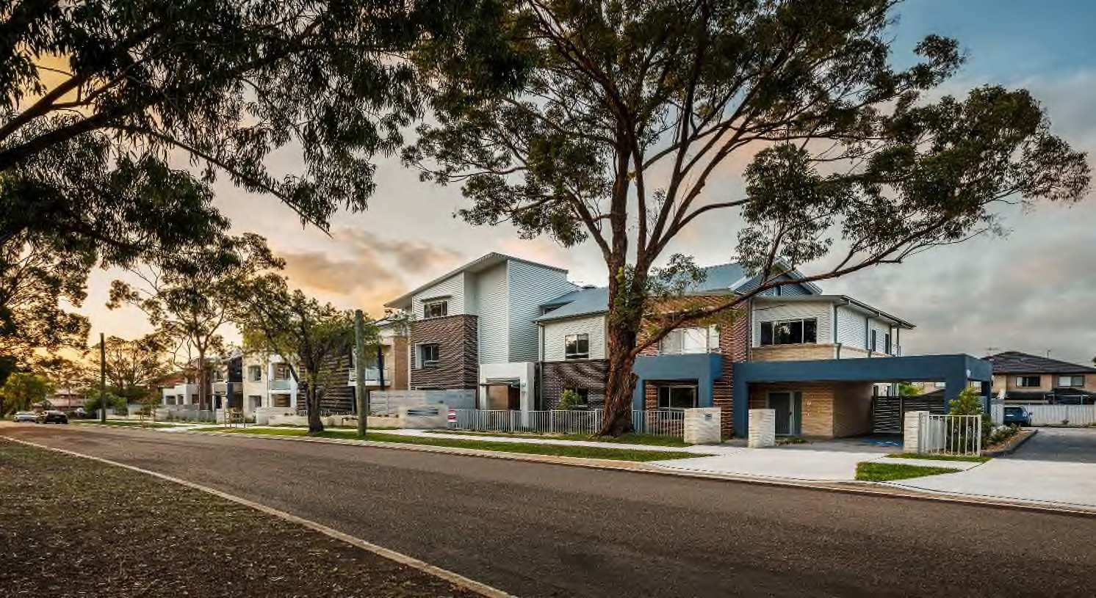
Stage 2 Submission Form Redevelopment Business Case
Policy for Community Housing Provider-led Redevelopment of Social and Affordable Housing on LAHC-owned Land

Contents
CHP Build on LAHC Land 3
Submission Form 3
Section 1 – Submission Information 5
Section 2 – Project Outcomes 6
Section 3 – Detailed Project Feasibility Assessment 10
Section 4 – Project Viability 17
Section 5 – CHP Capacity 19
Section 6 – Tenant Considerations 22
Section 7 – Operational Considerations 23
Section 8 - Acceptance of terms and conditions 24

CHP Build on LAHC Land
This document is the Stage 2 Submission Form - Redevelopment Business Case for Community Housing Providers to develop on land owned by the Land and Housing Corporation.

Submission Form
New South Wales Land and Housing Corporation (LAHC) invites eligible Community Housing Provider’s (CHP’s) to make a Stage 2 Submission for redevelopment under LAHC’s Community Housing Provider-led Redevelopment of Social and Affordable Housing on LAHC-owned Land Policy (Policy). Please complete this Stage 2 Submission Form and Annexure A (the ‘B Paper’), Stage 2 Financial Model, along with an Independent Opinion of Project Feasibility and email the Submission Form plus attachments to CHPLedRedevelopment@facs.nsw.gov.au.
The Stage 2 Submission Form, B Paper, Stage 2 Financial Model, Independent Opinion of Project Feasibility and supporting documentation should be sent in one email with the subject line ‘CHP Redevelopment on LAHC Land – Stage 2 Submission – <CHP Name> – <Name of Project>’.
Please note: the ancillary Stage 2 Financial Model should be completed prior to completing this Stage 2 Submission Form as the information within it is summarised in the questions in this submission. It is also a mandatory requirement to provide an Independent Opinion of Project Feasibility with the submission.
As part of providing a submission, you confirm that you have read and that the submission will comply with:
- Policy: Policy on Community Housing Provider-led Redevelopment of Social and Affordable Housing on LAHC-owned Land); and
- ‘Process and Conditions’ document.
Stage 2 Submissions will be treated as commercial in confidence and non-binding on both parties (the CHP and LAHC).
If you have any questions prior to lodging a submission, please contact the team through CHPLedRedevelopment@facs.nsw.gov.au.
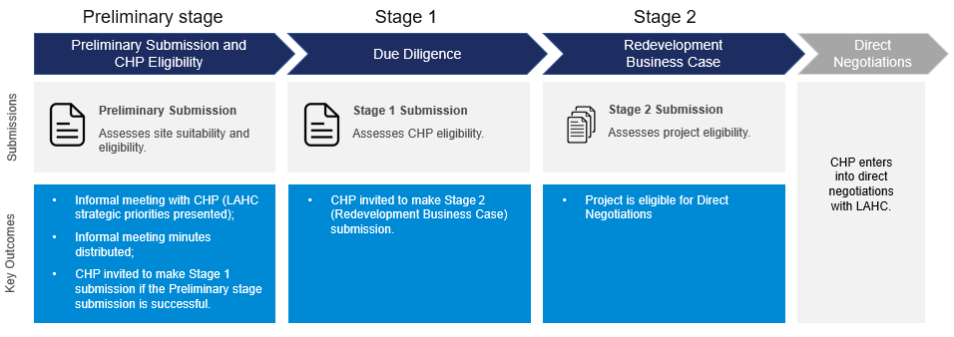
You are here

Section 1 – Submission Information
This section will be used to identify and align the Stage 2 Submission with the Stage 1 and Preliminary Submissions provided earlier in the Submission Process.
Table 1.1. Principal Applicant (i.e. the CHP / institution).
# | Principal Applicant | Provide details here
1 | CHP name | Click or tap here to enter text.
2 | Submission ID | Click or tap here to enter text.
3 | Proposed Site address | e.g. 11 Example street, Suburb, 1234
4 | PRN | Click or tap here to enter text.

Section 2 – Project Outcomes
The information in this section will contribute to the assessment of the Submission as per the Policy. It will assist LAHC to:

- Understand the concentration of social housing within the precinct or neighbourhood. (Q4 and Q5)
- Ensure that the project is increasing the proportion of well-designed, fit for purpose and appropriately sized homes in the social housing portfolio and reducing the average age of social housing properties. (Q6)
- Evaluate the number of replacement and new supply social housing dwellings and distribution of social, affordable and private rental outcomes. (Q1, Q2 and Q3)
- Ensure that the project is contributing to CHP portfolio outcomes. (All questions)
- Evaluate the project’s alignment with LAHC’s strategic priorities and plans for the LGA, including existing or planned LAHC renewal projects. (All questions)

Question 1 - Dwelling Mix Overview
Complete the table below with the number of dwellings per rental type for the existing site. If there are no changes to the dwelling mix, please insert “as per Stage 1”.
Table 2.1. Dwelling Mix Overview. Note: this table was provided in the Preliminary Submission and in the Stage 1 submission and is included to allow for any changes that may have arisen from any of the previous stages.
Total number and dwelling typology | Currently on-site  (total number) | Planning Control  (total number) | Proposed construction  (total number)
Social Housing dwellings | e.g.  2 x 2 bed unit  4 x 3 bed unit | e.g.  4 x 2 bed townhouse  5 x 2 bed cottage  4 x 3 bed villa | e.g.  2 x 2 bed townhouse  4 x 2 bed cottage  4 x 3 bed villa
Affordable Housing dwellings | Click or tap here to enter text. | Click or tap here to enter text. | Click or tap here to enter text.
Market Housing dwellings | Click or tap here to enter text. | Click or tap here to enter text. | Click or tap here to enter text.
Other  (please list in comments) | Click or tap here to enter text. | Click or tap here to enter text. | Click or tap here to enter text.

Question 2 – Dwelling Mix Changes

Please only use this section to provide any changes to the rationale for the above dwelling mix provided in the Stage 1 submission. An outline of what to include as part of the expected response has been provided in the description box.
(max 1/2 page)
Include:
- Explain why the dwelling mix has been changed e.g. as a result of discussions with LAHC; change of approval pathways etc;
- How is the potential of the site being maximising;
- Explain the dwelling mix between;
  - Social, affordable, and market housing;
  - The mix of dwellings e.g. 2 bed vs 3 bed;
  - The dwelling typology e.g. villa vs unit;
- Explain any other revenue opportunities including commercial or sub-lease opportunities;
- Elaborate the design considerations in relation to the planning approval; and
- Describe how the proposal complies with the development requirements, including relevant planning controls.

Question 3 – Maximised Planning
Provide a detailed overview of how the development maximises available planning controls.
(max 1 page)
Mandatory Inclusions:
- A detailed description of how the proposal maximises FSR under planning control;
- A detailed description of how the proposal maximises available building height under planning control; and
- A detailed description of design alternatives that were considered and why are they not considered viable.

Example:
2 units were sacrificed to deliver good shared and public spaces as aligned to LAHC’s Good Design for Social Housing guidelines.

Question 4 – Housing Demand
How does this project help address the demand for social and affordable housing in the area?
(max 1 page)
Mandatory inclusions:
- The intended outcomes of the proposed redevelopment;
- The concentration of social housing within the precinct or neighbourhood;
- The proportion of well-designed, fit for purpose and appropriately sized homes in the social housing portfolio;
- Reducing the average age of social housing properties;
- Number of replacement and new supply social housing dwellings and distribution of social, affordable and private rental outcomes.

Optional inclusions:
- Income per capita of the area;
- Area profile; and
- Area population.

Question 5 – Demand Demographics
How does the development design and dwelling mix align with the demographic of demand for social and affordable housing in the area?
(max 1 page)
Mandatory inclusions:
- The development’s dwelling mix in relation the target cohort to be serviced;
- The relative demand for social / affordable / private housing; and
- The due diligence undertaken in identifying the target cohort and assessing the demand in relation to the selection of the dwelling mix.

Question 6 – Good Design for Social Housing
How will LAHC’s Good Design for Social Housing guidelines be addressed for the social housing dwellings?
(max 1 page)
Successful social housing requires a thoughtful design process. Please advise how the four goals of wellbeing, belonging, value and collaboration will be achieved in your design of the social housing dwellings.

Section 3 – Detailed Project Feasibility Assessment
The information in this section will contribute to the assessment of the submission as per the Policy. It will assist LAHC to:

- Understand the capacity and limitations of the proposed redevelopment site. (Q7i, Q7ii, Q8)
- Understand the overall project costs. (Q9)
- Evaluate the detailed cash flow over the lease term, including project funding structure (equity/debt/grant etc) and expected revenues and costs. (Q10, Q11, Q12, Q16)
- Evaluate the CHP’s access to finance and funding options. (Q13, Q14, Q15)
- Understand the timeframe for commencement and completion of the development (Q9)
Please complete and summarise the relevant information from the ancillary Stage 2 Financial Model prior to answering the questions in this section.

Question 7 i – Site Condition Investigations
What investigations into the site have been conducted and what are the findings?
(max 1 page)
Table 3.1. Site Condition Investigations (Please add additional rows to the table if needed).
Investigation | Findings | Comment (if relevant)
e.g. soil survey. | Click or tap here to enter text. | Click or tap here to enter text.
e.g. contamination report. | Click or tap here to enter text. | Click or tap here to enter text.
e.g. latent condition report. | Click or tap here to enter text. | Click or tap here to enter text.
Click or tap here to enter text. | Click or tap here to enter text. | Click or tap here to enter text.
Click or tap here to enter text. | Click or tap here to enter text. | Click or tap here to enter text.

Question 7 ii – Site Condition at the End of Lease
Please provide details regarding the intended condition of the site (including dwellings) when returned to LAHC at the end of the lease term.
Consider:
- The retaining, refurbishing, or demolition of buildings on the site.

Question 8 – Site Plan Overview
Complete the planning overview table below. This section will be used to assess the project feasibility and viability, and that the site is maximised in relation to its planning approval pathway.
Table 3.2. Site Plan Overview.
Building Element | Current Site | Planning Control | Proposed Site | Comments (if necessary)
Height (in relation to the land) | e.g. 25m | e.g. 25m | e.g. 25m | Click or tap here to enter text.
FSR | e.g.  Floor Space: 100sqm  Site area: 200sqm  FSR = 0.5:1 | e.g.  Floor Space: 100sqm  Site area: 200sqm  FSR = 0.5:1. | e.g.  Floor Space: 100sqm  Site area: 200sqm  FSR = 0.5:1 | Click or tap here to enter text.
Parking spaces | Click or tap here to enter text. | Click or tap here to enter text. | Click or tap here to enter text. | Click or tap here to enter text.
Common Areas/ Landscaped Areas | Click or tap here to enter text. | Click or tap here to enter text. | Click or tap here to enter text. | Click or tap here to enter text.

Question 9 – Development Costs
Please provide a summary of the development costs for this proposal.
Please consider the following:
- Year 1 refers to the first year that the development commences;
- Financial information must have clear reconciliation to all attached financial models; and
- The first five years have been specified as it is expected that the development will be completed over that time. If the development is expected to take greater than 5 years, average the total cost over the 5 years.
Table 3.3. Development Costs.
Cost Category / Year | 1 | 2 | 3 | 4 | 5 | Comments (if relevant)
Design / Planning | $ AUD | $ AUD | $ AUD | $ AUD | $ AUD | Click or tap here to enter text.
Construction | $ AUD | $ AUD | $ AUD | $ AUD | $ AUD | Click or tap here to enter text.
Contingency | $ AUD | $ AUD | $ AUD | $ AUD | $ AUD | Click or tap here to enter text.
Other | $ AUD | $ AUD | $ AUD | $ AUD | $ AUD | Click or tap here to enter text.

Question 10 – Operational Cash Flow
Please provide a summary of the projected operational cash flow for this proposal.
Please consider the following:
- Year 1 refers to the first year that the development commences; and
- Averaged have been asked for 5 year periods from year 6 for the purposes of simplicity.
Table 3.4. Projected Operational Cash Flow Summary.
Year | 1 | 2 | 3 | 4 | 5 | 6-10 (average) | 11-20 (average) | 21-30 (average) | 31-40 (average) | 40-49 (average)
Revenue (s Q12 for breakdown) | $ AUD | $ AUD | $ AUD | $ AUD | $ AUD | $ AUD | $ AUD | $ AUD | $ AUD | $ AUD
Operating Expenses (s Q13 for breakdown) | $ AUD | $ AUD | $ AUD | $ AUD | $ AUD | $ AUD | $ AUD | $ AUD | $ AUD | $ AUD

Question 11 – Revenue
Please provide a breakdown of revenue in the first year of operations for this proposal.
Please consider the following:
- The total of all expense items must reconcile to year 1 revenue in Table 4.2;
- Year 1 refers to the first year that the development is operational; and
- Financial information must have clear reconciliation to all attached financial models.

Table 3.5. Revenue Breakdown (estimated).
Expense Item | Amount ($ AUD) | Escalation Rate (%)
Rent: Social dwellings* | $ AUD | e.g. 2.2 %
Rent: Affordable dwellings* | $ AUD | e.g. 2.2 %
Rent: market dwellings | $ AUD | e.g. 2.2 %
Rent: commercial tenants (if applicable) | $ AUD | e.g. 2.2 %
Revenue: other | $ AUD | e.g. 2.2 %
Total | $ AUD | N / A
* Please provide additional details at Q17- Assumptions
Question 12 – Operating Expenses
Provide a breakdown of the operating expenses in the first year of operations for this proposal.
Please consider the following:
- The total of all expense items must reconcile to year 1 operating expenses in Table 4.2;
- Year 1 refers to the first year that the development is operational; and
- Financial information must have clear reconciliation to all attached financial models.

Table 3.6. Operating Expense Breakdown.
Expense Item | Amount ($ AUD) | Escalation Rate (%)
Tenancy & Property Management | $ AUD | e.g. 2.2 %
Planned & Responsive Maintenance | $ AUD | e.g. 2.2 %
Insurance | $ AUD | e.g. 2.2 %
Council Rates | $ AUD | e.g. 2.2 %
Water Rates | $ AUD | e.g. 2.2 %
CHP Corporate Overhead & Misc | $ AUD | e.g. 2.2 %
Other | $ AUD | e.g. 2.2 %
Total | $ AUD | N / A

Question 13 – Access to finance and funding options
Provide a breakdown of all funding sources for this Submission.
Please note the following when completing Table 3.7 below::
- The total funding amount must align to the development cost in Question 9;
- Debt and Equity figures must align to the Debt to Equity Ratio in Question 14; and
- Add additional rows as required.
Table 3.7. Funding Breakdown.
Funding Source | Finance Type | Amount ($ AUD) | Security | Term (if relevant)
e.g. CHP Retained Earnings | e.g. Equity | $ AUD | e.g. Common Equity | e.g. N/A
e.g. AMP Drawdown Facility | e.g. Senior Debt | $ AUD | e.g. Security over all of CHP’s portfolio | e.g. 25 years
e.g. NHFIC Grant (please specify grant) | e.g. Grant | $ AUD | N / A | Please specify timeframe is applicable
Total | N / A | $ AUD | N / A | N / A

Question 14 – Debt to Equity Ratio
Provide a breakdown of all debt to be employed for this proposal.
Table 3.8. Debt Breakdown. Note: complete this table only if the proposed redevelopment has a source of debt funding.
Please consider the following:
- Debt and Equity figures must align to the figures Question 13.

Funding Source | Value
Total Debt | $ AUD
Total Equity | $ AUD
Debt to Equity Ratio | e.g. 3:1
Will any property that LAHC has interest proposed to be used as security for the Debt? | Please answer Yes or No, and outline which property(s) are proposed to be used as security for the Debt

Question 15 – Debt Coverage
Complete the following table with key debt coverage metrics for this proposal.
Table 3.9. Debt Coverage Metrics. Note: complete this table only if the proposed redevelopment has a source of debt funding.
Coverage Type | Minimum - Overall | Median - Overall
Interest Coverage Ratio | e.g. 2.4x | e.g. 2.4x
Debt Service Coverage Ratio | e.g. 2.4x | e.g. 2.4x
Loan Life Coverage Ratio (optional) | e.g. 2.4x | e.g. 2.4x

Question 16 – Assumptions
Complete the following table with key assumptions made in the financial model for this proposal.
Table 3.10. Financial Model Assumptions (Please add additional rows as needed).
Assumption | Unit | Value | Comments (if relevant)
e.g. Occupancy Rate | e.g. % | e.g. 80% | Click or tap here to enter text.
e.g. Average Interest Rate | e.g. % | e.g. 3% | Click or tap here to enter text.
e.g. Rental Growth Rate | e.g. % | e.g. 3% | Click or tap here to enter text.
e.g. Cost Escalation Rate | e.g. % | e.g. 3% | Click or tap here to enter text.
Click or tap here to enter text. | Click or tap here to enter text. | Click or tap here to enter text. | Click or tap here to enter text.
Click or tap here to enter text. | Click or tap here to enter text. | Click or tap here to enter text. | Click or tap here to enter text.

Section 4 – Project Viability
The information in this section will contribute to the assessment of the submission as per the Policy. It will assist LAHC to understand the project complexity (Q 18)

Question 17 – Risk Management
Provide a detailed overview of all real and present risks, and the strategies to mitigate them. Include both development and operational risks, their respective impact and mitigation strategy as well as what (if any) assistance is required from LAHC.
(max 2 pages):
Table 4.1. Risk Management.
- As a guide, LAHC would expect to see approximately 15 major risks that are likely to affect the project.

Risk | Impact | Mitigation Strategy
e.g. developer counterparty risk. | e.g. developer insolvency creating exposure to $x. | Click or tap here to enter text.
e.g. extended development delays. | e.g. x month development delay would cause increased development cost and lost revenue creating $x loss.  Impact on tenant re-location plan. | Click or tap here to enter text.
e.g. major site hazard. | e.g. hazard on site creating up $x of remediation works in addition a x month development delay would cause increased development cost and lost revenue creating $x loss.  Impact on tenant re-location plan. | Click or tap here to enter text.
e.g. yield / occupancy rate reduction. | e.g. reduced occupancy rate by x% can create cash flow impact $x p.a. | Click or tap here to enter text.
e.g. interest rate change. | e.g. increased interest rate by x% increases loan service by $x p.a. | Click or tap here to enter text.
Inability to access Commonwealth Rent Assistance. | e.g. reduce income by $x. | Click or tap here to enter text.
Click or tap here to enter text. | Click or tap here to enter text. | Click or tap here to enter text.
Click or tap here to enter text. | Click or tap here to enter text. | Click or tap here to enter text.
Click or tap here to enter text. | Click or tap here to enter text. | Click or tap here to enter text.
Click or tap here to enter text. | Click or tap here to enter text. | Click or tap here to enter text.
Click or tap here to enter text. | Click or tap here to enter text. | Click or tap here to enter text.
Click or tap here to enter text. | Click or tap here to enter text. | Click or tap here to enter text.
Click or tap here to enter text. | Click or tap here to enter text. | Click or tap here to enter text.
Click or tap here to enter text. | Click or tap here to enter text. | Click or tap here to enter text.
Click or tap here to enter text. | Click or tap here to enter text. | Click or tap here to enter text.
Click or tap here to enter text. | Click or tap here to enter text. | Click or tap here to enter text.
Click or tap here to enter text. | Click or tap here to enter text. | Click or tap here to enter text.
Click or tap here to enter text. | Click or tap here to enter text. | Click or tap here to enter text.
Click or tap here to enter text. | Click or tap here to enter text. | Click or tap here to enter text.
Click or tap here to enter text. | Click or tap here to enter text. | Click or tap here to enter text.

Section 5 – CHP Capacity
The information in this section will contribute to the assessment of the submission as per the Policy. It will assist LAHC to:

- Evaluate whether the CHP’s capability and capacity is commensurate with the complexity of the project. (Q18 and Q19)
- Understand the CHP’s partnership arrangements. (Q20)
- Evaluate the CHP’s financial viability and financial risk exposure. (Q18)

Question 18 – CHP Financial Viability
Complete the following table regarding financial viability or, submit the data provided to the Registrar as an attachment, where the data is not more than 3 months old.
Note: All table fields are mandatory.
Table 5.1 Financial Viability Overview.
Financial Metric | Previous Financial Year | Current Financial Year | Next Financial Year (forecast) | Comments (if necessary)
Total Debt | e.g. $100m | e.g. $100m | e.g. $100m | Click or tap here to enter text.
Total Equity | e.g. $100m | e.g. $100m | e.g. $100m | Click or tap here to enter text.
Profit / Loss | e.g. $10m | e.g. $10m | e.g. $10m | Click or tap here to enter text.
# of Dwellings Managed | e.g. 400 | e.g. 400 | e.g. 400 | Click or tap here to enter text.
# of Dwellings Owned | e.g. 300 | e.g. 300 | e.g. 300 | Click or tap here to enter text.
Interest Coverage Ratio | e.g. 2.1x | e.g. 2.1x | e.g. 2.1x | Click or tap here to enter text.
Debt Service Coverage Ratio | e.g. 2.1x | e.g. 2.1x | e.g. 2.1x | Click or tap here to enter text.

Question 19 – Litigation and Known Financial Risks
Complete the following declaration regarding litigation and known financial risks.
Table 5.2. Litigation and known financial risks.
Terms and conditions | Provide response here
 | Yes | No
The CHP acknowledges that there is no exposure to any material litigation or known material financials risks that may affect their ability to carry out the project set out in the Submission, including entering into a lease with LAHC | ☐ | ☐
If no is selected, please provide a summary of the any material litigation or known material financials risks below.
Click or tap here to enter text.

Question 20 – Partnership Arrangements
Provide an overview of proposed partnerships to undertake any aspect including development, construction, tenant servicing, maintenance etc.
(max 1 page)
Mandatory inclusions:
- In this section, include any and all relationships that you may have to deliver the development and operation of the project (including how these partnerships address the NSW Government Policy on Aboriginal Procurement and the NSW Government Procurement Guideline on skills, training and diversity in the construction industry; and
- Add additional rows as required.

Table 5.3. Partnership Arrangements.
Partner Name | Partner Role | Arrangement
Click or tap here to enter text. | This may include: Contractors, Sub-contractors, etc. | In this section, include a description of the following:  - Details of the partnership (length, type, contractual arrangements etc).
Click or tap here to enter text. | Click or tap here to enter text. | Click or tap here to enter text.
Click or tap here to enter text. | Click or tap here to enter text. | Click or tap here to enter text.
Click or tap here to enter text. | Click or tap here to enter text. | Click or tap here to enter text.
Click or tap here to enter text. | Click or tap here to enter text. | Click or tap here to enter text.

Section 6 – Tenant Considerations
The information in this section will contribute to the assessment of the submission as per the Policy. It will assist LAHC to evaluate whether there are suitable relocation arrangements for tenants. (Q22)

Question 21 – Tenant Re-Location Plan
Please provide a plan for re-locating all tenants on the existing site.
(max 1 page)
Table 6.1. Tenant Re-Location Plan.
Re-Location Element | Plan
Overview | In this section, include a description of the overall plan and approach to tenant re-location.
Existing Tenants | A description of the tenants residing on the existing site.
Timelines | In this section, include:  - Timelines for the re-location of all tenants of the existing site.
Locations | In this section, include:  - An overview of the re-location buildings; and  - The number of tenants to be moved to each location.
Alternative Arrangements | In this section, include a description of:  - What alternative arrangements are made for delays to the development; and  - What alternative arrangements are made for the unavailability of planned re-location dwellings.
Community Impacts | In this section, include a description of the potential community impacts that will result from the Tenant Re-Location Plan and what strategies are employed to reduce these impacts.

Section 7 – Operational Considerations
The information in this section will contribute to the assessment of the submission as per the Policy. It will assist LAHC to:

- Evaluate whether there are suitable operational considerations for the project. (Q22)

Question 22 – Asset Maintenance and Tenancy Management Plans
Please provide a plan for maintaining the development. Please note, LAHC’s Asset Management Framework will apply in respect of Asset Maintenance.
(max 1 page)
Table 7.1. Asset Maintenance and Tenancy Management Plan.
Element | Plan
Major Periodic Maintenance | In this section, include:  - A description, in general terms, of the approach;  - Regularity of maintenance;  - Budget allocated; and  - Partners or contractors to be used.
Ongoing Maintenance | In this section, include:  - A description, in general terms, of the approach;  - Regularity of maintenance;  - Budget allocated; and  - Partners or contractors to be used.
Tenancy management | In this section, include:  - Tenant requests for the building; and  - Program delivery capability. Include the programs to be delivered; resource capability; the funding to utilise these programs.

Section 8 - Acceptance of terms and conditions
This section will be used to determine if the CHP accepts the terms and conditions outlined by ‘Process and Conditions’ document. The CHP can respond to the criteria by selecting the appropriate option from the respective drop-down menu. Please note that the submission may be rendered ineligible if the CHP does not accept the terms and conditions, and that the decision for the Submission to not proceed in the Submission process is at LAHC’s discretion.
Table 8.1. Acceptance of Terms and Conditions.
# | Terms and Conditions | Provide response here
23 | CHP confirms that it has read, understood, and accepts the information outlined in the ‘Process and Conditions’ document. This includes:  - The submission process;  - The commercial framework, including the described allocation of risk;  - The submission conditions;  - The responsibilities of the CHP and LAHC;  - Confidentiality; and  - Intellectual property.  (select from drop down) | Choose an item.
24 | CHP warrants that the contents of the Conflict of Interest and fair dealing statutory declaration made as part of the Stage 1 Submission remain valid and true, and that LAHC have been notified of any changes (if applicable) | Choose an item.
25 | CHP consents to LAHC obtaining any documents from the NSW Community Housing Registrar to assess financial capability and capacity  (select from drop down) | Choose an item.

Section 9 – Attachments
Please detailed the following table with the attachments to this form.
Table 9.1 Attachments.
Attachment | Mandatory? | Attached? | Comments (If relevant)
Project Plan | Yes | ☐
Financial Model | Yes | ☐
Development Application | No | ☐
Latent Condition Report | No | ☐
Site Survey Report | No | ☐
Other | No | ☐
Environmental Impact Statement | No | ☐
Statement of Environmental Effects | No | ☐
Species Impact Statement | No | ☐
BASIX Certificate | No | ☐
Site Plan | No | ☐
Site Drawings | No | ☐
 | No | ☐

© State of New South Wales through Department of Planning, Industry and Environment 2021. The information contained in this publication is based on knowledge and understanding at the time of writing April 2021. However, because of advances in knowledge, users are reminded of the need to ensure that the information upon which they rely is up to date and to check the currency of the information with the appropriate officer of the Department of Planning, Industry and Environment or the user’s independent adviser.

