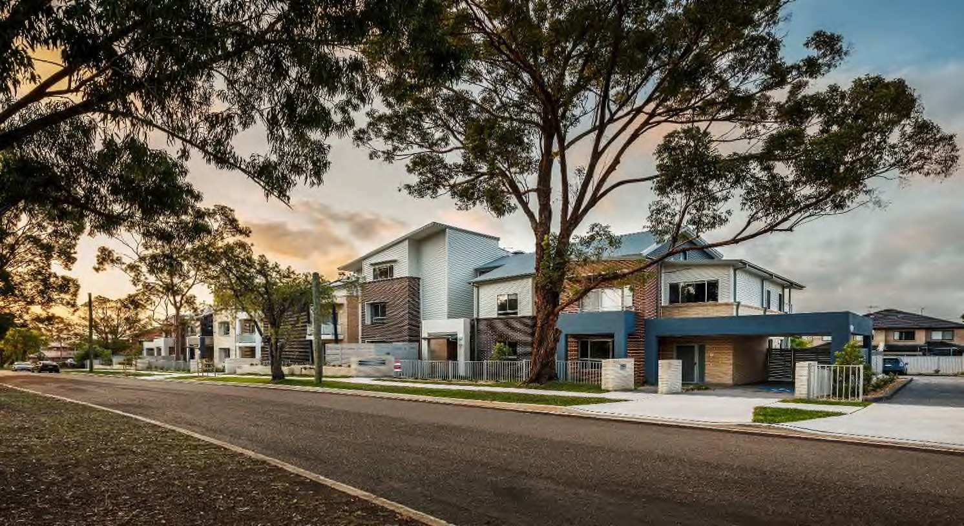
Preliminary Submission Form
Under the Policy on Community Housing Provider-led Redevelopment of Social and Affordable Housing on LAHC-owned Land

Contents
CHP Redevelopment on LAHC Land 3
Submission Form 3
Section 1 – Submission Overview 4
Section 2 – CHP Eligibility Criteria 5
Section 3 – Proposal Eligibility Criteria 6
Section 4 – Project Benefits 8
Section 5 – Acceptance of Terms and Conditions 9
Section 6 – Conflict of Interest and fair dealing statutory declaration 10
Section 8 – Attachments 12

CHP Redevelopment on LAHC Land
This document is the preliminary submission for Community Housing Providers to develop on land owned by the Land and Housing Corporation.

Submission Form
New South Wales Land and Housing Corporation (LAHC) invites eligible Community Housing Provider’s (CHP’s) to make a Preliminary Submission for redevelopment under LAHC’s Community Housing Provider-led Redevelopment of Social and Affordable Housing on LAHC-owned Land Policy. Please complete this Preliminary Submission Form and send the form plus attachments via the LAHC website.
As part of providing a submission, you confirm that you have read, and that the submission will comply with:
- Policy: Policy on Community Housing Provider-led Redevelopment of Social and Affordable Housing on LAHC-owned Land); and
- ‘Process and Conditions’ document available on the LAHC website.
Submissions in the preliminary stage will be treated as commercial in confidence and non-binding on both parties (the CHP and LAHC).
If you have any questions prior to making your submission, please contact the team through CHPLedRedevelopment@facs.nsw.gov.au.
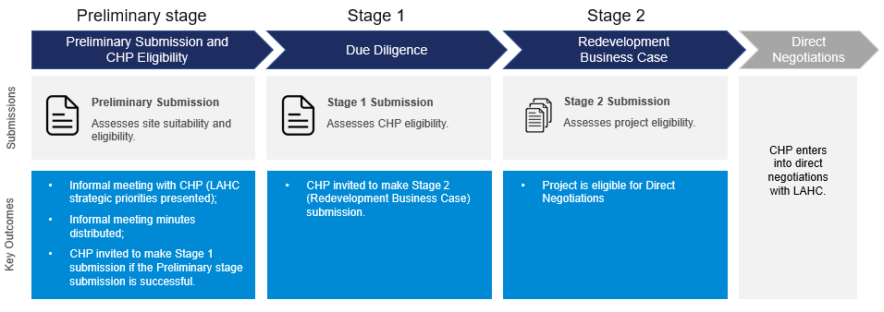
You are here

Section 1 – Submission Overview
Please provide details on the Principal Applicant (i.e. the Community Housing Provider [CHP]), the Principal Contact, and the Proposed Site.
Table 1.1. Principal Applicant (i.e. the CHP).
# | Principal Applicant | Provide details here
1 | CHP name | Click or tap here to enter text.
2 | ABN | Click or tap here to enter text.
4 | Postal Address | Click or tap here to enter text.
5 | Website | Click or tap here to enter text.
Table 1.2. Principal Contact.
# | Principal Contact | Provide details here
6 | Name | Click or tap here to enter text.
7 | Position / title | Click or tap here to enter text.
8 | Phone | Click or tap here to enter text.
9 | Email | Click or tap here to enter text.
Table 1.3. Proposed Site information.
# | Proposed Site Information | Provide details here
10 | Lot and Deposited Plan ID | e.g. DP 12345678
11 | Proposed Site address | e.g. 11 Example street, Suburb, 1234
12 | Property Reference Number (PRN) | e.g. 34567
13 | Is the Property currently tenanted? If no, please provide further details as to why. | Choose an item.  e.g. the property is void, there are insurance issues, the property is fire damaged etc.

Section 2 – CHP Eligibility Criteria
This section will be used to assess whether the CHP is eligible to continue to the next stage of the process under the Policy. The CHP can respond to the criteria by selecting the appropriate option from the respective drop-down menu for each question. Please note that if any of these conditions are not met, it may render the submission ineligible for assessment under the Policy, at LAHC’s discretion.
Table 2.1. CHP eligibility evaluation criteria.
# | Eligibility Criteria | Provide details here
14 | CHP is registered as Tier 1 or Tier 2  (select from drop down) | Choose an item.
15 | Is the CHP aware of any regulatory compliance issues they have?  (select Yes or No from drop down) | Choose an item.
16 | Does the CHP have unresolved contractual issues with a LAHC lease or other contractual agreement?  (select Yes or No from drop down) | Choose an item.
17 | If the CHP has indicated that there are either compliance issues or unresolved contractual issues, please provide details.  Note: Please use an Attachment if there is considerable information to disclose. | Click or tap here to enter text.
18 | CHP has a current lease from LAHC on the proposed site and/or on an adjacent site that is not expiring within the next 12 months?  (select Yes or No from drop down)  Note: Please provide a copy of the lease as an Attachment to this submission | Choose an item.
19 | Does the CHP consent to LAHC obtaining any documents from the NSW Community Housing Registrar to assess financial capability and capacity  (select from drop down) | Choose an item.

Section 3 – Proposal Eligibility Criteria
This section will be used to assess whether the proposal is eligible under the Policy. Table 3.1 will be used to assess the proposal’s expected timeframes, cost, and compliance to planning controls under the Policy. Table 3.2 provides the CHP with the opportunity to demonstrate the potential uplift from the proposed redevelopment. It is essential that the CHP provides further detail on how the proposed dwelling mix maximises the potential of the site under the existing planning controls in question 28.
Table 3.1. Proposal eligibility evaluation criteria.
# | Proposal Information | Provide details here
20 | The duration of the requested lease is 49 years or less  (select from drop down, and please advise the proposed duration of the lease in the free text box) | Choose an item.
21 | Proposal does not require a capital contribution from LAHC  (select Yes or No from drop down) | Choose an item.
22 | Estimated length of construction | Click or tap to enter a date.
23 | Estimated capital cost of construction | e.g. $ 10,000,000
24 | Please confirm that the development and assessment of the Proposal does not require LAHC to act in its capacity as a consent authority under Part 5 of the Environmental Planning and Assessment Act 1979 (NSW).  (select Yes or No from drop down)  If your answer is ‘yes’ please provide further information detailing why LAHC is required to act as a consent authority for the Proposal (Please note that submissions that request LAHC to act as a consent authority may be deemed ineligible under the Policy). | Choose an item.  Click or tap here to enter text.
25 | Do the current planning controls for the Property support the redevelopment Proposal?  (select from drop down) | Choose an item.

Question 26
Table 3.2. Dwelling mix overview.
Total number and dwelling typology | Currently on-site  (total number) | Planning Control  (total number) | Proposed construction  (total number)
Social Housing dwellings | e.g.  2 x 2 bed unit  4 x 3 bed unit | e.g.  4 x 2 bed townhouse  5 x 2 bed cottage  4 x 3 bed villa | e.g.  2 x 2 bed townhouse  4 x 2 bed cottage  4 x 3 bed villa
Affordable Housing dwellings | Click or tap here to enter text. | Click or tap here to enter text. | Click or tap here to enter text.
Market Housing dwellings | Click or tap here to enter text | Click or tap here to enter text. | Click or tap here to enter text.
Other  (please list in comments) | Click or tap here to enter text. | Click or tap here to enter text. | Click or tap here to enter text.

Question 27

Additional comments to provide rationale for above proposed dwelling mix (max 1 paragraph)
Click or tap here to enter text.

Section 4 – Project Benefits
This section will be used to assess whether the proposal aligns to the NSW Government’s priorities and forecasts, LAHC’s Portfolio Strategy, and LAHC’s LGA Strategies (if developed) relevant to social and affordable housing. A structured response template has been provided below in question 28 and should be used as a guide to address the intended outcomes of the proposal, and the demand for social and affordable housing in the relevant Local Government Area. The response should include a combination of qualitative and quantitative evidence to support the need for the proposal. Please provide at least three intended outcomes. The response should be a no more than one page in length.

Question 28

Provide a summary on the intended outcomes for the redevelopment, and how the redevelopment responds to the NSW Government’s needs forecasts and priorities. (max half a page)
Example:
Intended outcomes
- Maximising social housing
- Maximising the potential of the site in the context of the local government area
- Improve housing options for target clients
Discuss, in general terms, the demand for the local government areas. Include the type of cohort and the current waiting list for social housing services.

Section 5 – Acceptance of Terms and Conditions
This section will be used to determine if the CHP accepts the terms and conditions outlined by ‘Process and Conditions’ document. The CHP can respond to the criteria by selecting the appropriate option from the respective drop-down menu. Please note that the submission may be rendered ineligible if the CHP does not accept the terms and conditions.
Table 5.1. Acceptance of Terms and Conditions.
# | Terms and Conditions
29 | The CHP confirms that it has read, understood, and accepts the information outlined in the ‘Process and Conditions’ document. This includes:  - The submission process;  - The commercial framework, including the described allocation of risk;  - The submission conditions;  - The responsibilities of the CHP and LAHC;  - Confidentiality; and  - Intellectual property.  (select from drop down)
 | Choose an item.

Section 6 – Conflict of Interest and fair dealing statutory declaration
The Conflict of Interest and Fair Dealing Statutory Declaration is made in respect of the Submission and the Policy on Community Housing Provider-led Redevelopment of Social and Affordable Housing on LAHC-owned Land (together the ‘Project’).
You must complete the Conflict of Interest and Fair Dealing Statutory Declaration set out below. If the CHP is a company, it must be sworn by a director or other officer holder who has the power to bind the CHP.
I,.................................................................................................................................................
(full name, address and occupation of the person making this Declaration)

DO SOLEMNLY AND SINCERELY DECLARE that, in respect of the Project, that:
1. I am a [insert: director/secretary or other officer] of [insert name of CHP] (“CHP”) and duly authorised to make this statutory declaration on the CHP's behalf and on behalf of:
(a) each employee and officer employed by the CHP or any Related Body Corporate of the CHP; and
(b) each person, company or entity engaged by the CHP or any Related Body Corporate of the CHP in connection with the Project including, without limitation, any contractor, consultant, agent or professional advisor, (each a "CHP Related Person").
2. I make this declaration on behalf of the CHP, on behalf of myself and on behalf of each CHP Related Person.
3. In lodging a submission for the Project the CHP was not acting and is not now acting on behalf of any third party, other beneficial interest or as trustee for any third party.
4. To the best of my knowledge and belief, after due enquiry, no family relationship exists between on the one hand, the CHP or any CHP Related Person directly or indirectly involved in the preparation of the submissions for the Project and on the other hand, any member, employee or officer of LAHC or the Department of Planning, Industry and Environment, except as set out in the ‘Conflict of Interest’ section of this statutory declaration.
5. Neither the CHP nor any CHP Related Person has engaged in any unethical behaviour or made any political donations with the intention (directly or indirectly) of influencing a decision or seeking, or sought or obtained an unfair advantage in obtaining business with LAHC or in connection with a submission in respect of the Project (including collusive behaviour with other CHPs).
6. The CHP has not entered into any agreement or understanding (verbally or otherwise otherwise) with a third party, which would confer on a third party a beneficial or financial interest in the Project.
7. Neither I nor the CHP has been convicted of any criminal offence.
8. Neither I or (to the best of my knowledge and belief) any member of the Board or any Officer of the CHP has been accused of any corrupt conduct in, or given any false or misleading statements to, the NSW Independent Commission Against Corruption or to any State or Federal government body.
9. I am aware that LAHC will rely on this statutory declaration.
10. The CHP will notify LAHC in writing immediately if any statement in this statutory declaration becomes incorrect, with full details.
11. The CHP will notify LAHC in writing immediately if any conflict of interest arises or which it perceives may arise during the course of the Project.
12. The CHP warrants that the Commonwealth Treasurer cannot prohibit the CHP entering into and completing a contract for lease (or other legal binding document) in connection with the Project , under the Foreign Acquisitions and Takeovers Act 1975.

Conflict of Interest
One section below must be completed.

Either Section 1 – You have no interests to declare
I do not have any existing or potential conflicts of interest (including any direct or indirect financial, personal, or any other interest or association) to declare that may create, or be perceived to create, a conflict of interest in this project.

Or Section 2 – You have interests to declare
I have the following conflict(s) of interest to declare. (Describe below).

Declaration
And I make this solemn declaration conscientiously believing the same to be true and by virtue of the provisions of the Oaths Act 1900 (NSW).

Declared at [ Place ] on [ Date ]

[ Signature of declarant ] in the presence of a witness, who states:

I, __________________________ a ______________________________
[Name of authorised witness], [Qualification of authorised witness]

certify the following matters concerning the making of this statutory declaration by the person who made it.
[*Cross out any text that does not apply]

1. *I saw the face of the declarant.
OR
*I did not see the face of the declarant because the person was wearing a face covering, but I am satisfied that the person had a special justification for not removing the covering, and

2. *I have known the person for at least 12 months.
OR
*I have confirmed the person's identity using an identification document and the document I relied on was:

[Describe identification document relied on]

Date | Signature of authorised witness

Section 8 – Attachments
Optional: Please provide any supporting documentation that may support your preliminary submission.
Table 7.1. Attachments
Attachment | Comments (If relevant)
Existing Lease
Click or tap here to enter text. | Click or tap here to enter text.

© State of New South Wales through Department of Planning, Industry and Environment 2021. The information contained in this publication is based on knowledge and understanding at the time of writing April 2021. However, because of advances in knowledge, users are reminded of the need to ensure that the information upon which they rely is up to date and to check the currency of the information with the appropriate officer of the Department of Planning, Industry and Environment or the user’s independent adviser.

